Moore’s Law and More: Fast/Cheap Computing and What This Means for the Manager

6.1 Introduction

Learning Objectives
- Define Moore’s Law and understand the approximate rate of advancement for other technologies, including magnetic storage (disc drives) and telecommunications (fiber-optic transmission).
- Understand how the price elasticity associated with faster and cheaper technologies opens new markets, creates new opportunities for firms and society, and can catalyze industry disruption.
- Recognize and define various terms for measuring data capacity.
- Consider the managerial implications of faster and cheaper computing on areas such as strategic planning, inventory, and accounting.
Faster and cheaper—those two words have driven the computer industry for decades, and the rest of the economy has been along for the ride. Today it’s tough to imagine a single industry not impacted by more powerful, less expensive computing. Faster and cheaper puts mobile phones in the hands of peasant farmers, puts a free video game in your Happy Meal, translates your spoken restaurant order into a waiter’s native language, and drives the drug discovery that may very well extend your life.

Moore’s Law and How Managers Interpret It
This phenomenon of “faster, cheaper” computing is often referred to as Moore’s Law
Chip performance per dollar doubles every eighteen months.
, after the late Gordon Moore, Intel co-founder. Moore didn’t show up one day, stance wide, hands on hips, and declare “behold my law,” but he did write a four-page article for Electronics magazine, a give-away trade paper targeted at radio hobbyists, in which he described how regular advances in the process of chip making enabled more powerful chips to be manufactured at cheaper prices.
Moore’s Law isn’t really a law—not like the Newtonian Laws, Boyle’s Law, or others you may have learned about in physics class. Some get confused by this because Moore’s Law has “Law” in the name and is often presented in graphs that have neatly and consistently marched forward during the early decades of computing. Moore’s Law is really just an observation that led to a prediction of future events based on past outcomes. In hindsight, Moore seemed like a fortune teller, writing that the rate of fast/cheap computing will “lead to such wonders as home computers,” “terminals connected to a central computer, automatic controls for automobiles, and personal portable communications equipment”—a bold prediction made at a time when computers were room-sized and cost nearly $200,000 in today’s dollars.
It was Gordon Moore’s friend, legendary chip entrepreneur and Caltech professor Carver Mead, who later coined the “Moore’s Law” moniker. That name sounded snappy, plus as one of the founders of Intel, Moore had enough geek cred for the name to stick. Moore’s original paper offered language only a chip designer would love, so we’ll rely on the more popular definition: chip performance per dollar doubles every eighteen months (Moore’s original paper stated transistors per chip, a proxy for power, would double every two years, but many managerial sources will refer to the eighteen-month figure, so we’ll stick with that since managers are often blindsided by unanticipated rate and disruptive capabilities of technology change).
Moore’s Law applies to chips—broadly speaking, to processors as well as to chip-based storage. Think of this as the stuff in your consumer electronics that’s made out of silicon. The microprocessor
The part of the computer that executes the instructions of a computer program.
is the brain of a computing device. It’s the part of the computer that executes the instructions of a computer program, allowing it to run a Web browser, word processor, video game, or virus. Using our definition, for processors, Moore’s Law means that next-generation chips should be twice as fast in about eighteen months, but cost the same as today’s models (or from another perspective, in about a year and a half, chips that are the same speed as today’s models should be available for half the price). Intel has speculated that Moore’s Law may slow to a doubling every 2.5 years. Even at that rate, we’re still talking about ridiculously accelerating power and plummeting costs, a concept vital for managers to be aware of. But in some ways, computing performance today is advancing even faster than Moore predicted.

AI and Machine Learning—Faster than Moore’s Law
It’s important to recognize that while we have some evidence that Moore’s Law is slowing, we’re also seeing many key areas of computing improve on cost/performance curves at rates far greater than Moore’s Law. One area is in how quickly and cost effectively we can use technology to develop artificial intelligence (AI) and machine learning models. According to Stanford’s AI Index Report, the cost to train an image recognition model to the industry-standard 93 percent top-five accuracy on Imagenet, the benchmark dataset of 14 million labeled images in 2017, was $1,000 (cost of a decent laptop). Just three years later in 2020 it was $7.43 (less than a sandwich). In 2018 the time it took to train the model was 6.2 minutes. Two years later it was only 47 seconds.
Another study by researchers at the University of Aberdeen (United Kingdom) has shown that the performance of AI systems has been doubling every six months or so for the past decade. That’s much faster than Moore’s Law’s performance increases. AI is especially tricky to track since all of the “brains,” the processors, exist in the cloud. And for costs to stay low, the number of users and the revenue from those users needs to increase significantly, as well. But so far, it looks like the cloud and its artificial intelligence goodness will keep the spirit of Moore’s Law, fast/cheap computing—advancing at the same rates that keep us “well fertilized” in a hothouse of innovation. So if you ever hear old timers or doomsday articles forecasting “The End of Moore’s Law” (we’ve been seeing this since before the turn of the century), keep in mind the spirit of Moore’s prediction—fast/cheap computing advances, and with it, the manager’s corollary—that along with it are exploitable promise and devastating peril. Stay alert, continually monitor advancing technologies and their implication, and hopefully you’ll land on the “promise” side of the potential outcomes.

The End of Moore’s Law, but Not Really an End to Fast/Cheap Computing
Moore’s Law in terms of the density of transistors that we can pack onto chips is slowing down. As we get nearer the measured-in-molecules paths that guide electrons inside of chips, at some point we’ll hit the unyielding hand of Mother Nature where we simply can’t build components that are any smaller. When Apple introduced the A17Pro chip in its iPhone Pro line, the firm also stated that the 3nm process had electrical pathways that were only ten atoms wide. Pundits have been predicting the end of Moore’s Law by dates we’ve since zoomed past. And while the ability to pack logic into tiny spaces will meet its end at some point, squeezing chips into smaller spaces isn’t the only way to make computing faster and cheaper, and it’s important not to miss the forest because of the trees, or in this case, miss advancing performance improvement because we’re overly focused on transistor density.
When today’s managers talk about Moore’s Law, they’re not really referring to the transistor density and cost that Gordon Moore laid out in his 1965 paper; they’re referring more broadly to the relentless advance in fast/cheap computing. And this continues because of improved chip architectures, among other factors. Two ways we're seeing fast/cheap computing advance beyond predicted limits are improved chip design and offloading computing to the cloud. When Apple decided to abandon industry-standard Intel chips and instead go with its own custom silicon brains (dubbed M1, M2, etc.), it achieved dramatically faster computing with an additional bonus—the chips sipped less power. Apple did this not through some sort of Moore's Law–defying manufacturing breakthrough, but by designing chips better than Intel. Intel processors, while improved over time, are based on a standard that was introduced four decades earlier (this Intel standard is sometimes called the x86 standard). By abandoning old designs, Apple was free to make loads of improvements.
To see how Apple might boost performance, imagine that instructions on an Intel chip require traveling a microscopic distance of X, but Apple's design moves components around so those most-used instructions are now half the distance. All of a sudden Apple enables that instruction to happen at twice the speed! Also, Apple doesn't use Intel's old instructions; it has designed a new set of logic best suited for the current needs of its PCs, laptops, tablets, and mobile devices. Apple's chips are planned from the ground up around needs for more power-efficient computing, while Intel's original x86 designs were created before there were any laptop computers. Apple also designs special components—either on the chips inside the same package or added as custom “supporting processors” placed adjacent to the microprocessor—that are optimized for things that include graphics, machine learning, and security.
They are in fact some of the fastest laptop processors we’ve ever seen, and they deliver this performance with incredibly low power consumption. The M1 chip is so impressive, it’s been referred to as “black magic.”
—C. Schodt, Engadget, February 3, 2021 (on Apple’s First Generation of Intel-replacing M1 Chips)
One downside of radical redesign is that older software is not compatible with the instruction sets of these new chips. Code written for an old standard can act as a switching cost that limits moving to a new standard, so managers need to think through how switching costs can be lowered to the point where the new tech's benefits outweigh the burden of switching. Apple made making the switch easy by adding an emulator
A software-based interpreter that allows programs designed to run on one standard to be run on devices using a different standard. Using an emulator will be slower than executing code on the native, new standard, since this translation adds a step to accomplish before instructions can be run.
to each new Mac with the new chip. The emulator acts as a sort of real-time software interpreter so that programs created for Intel Macs could run on the new Apple silicon. Apple also provided software developers with new tools to take the programs they've written and translate them into native instructions optimized for new chips. The program that turns the code that a software developer writes into the instruction sets that a processor understands is called a compiler
A program that turns the code that a software developer writes into the instruction sets that a processor understands.
. Once software developers compile their code for the new chip, an emulator isn't needed, so their programs run even faster.
Figure 6.1 Emulators and Compilers Make It Easier to Switch to a New Standard
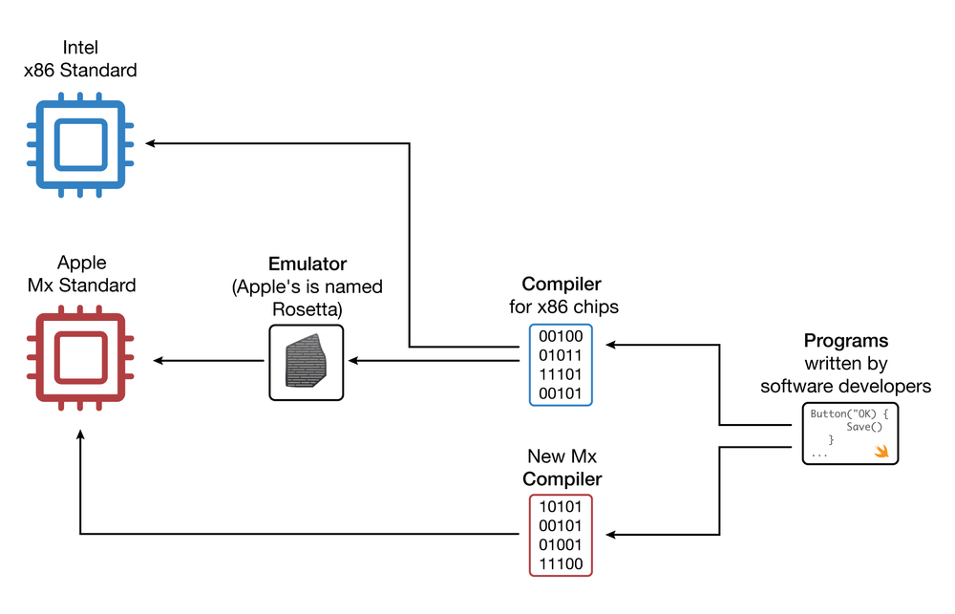
Source: John Gallaugher
Another way faster computing is made available is by off-loading the most complex tasks to the cloud. For example, while Apple does quite a bit of AI for things like voice recognition on the device itself, most of the implementation of Siri is “in the cloud” since a smartphone doesn't have enough processing power or storage to efficiently handle natural language interpretation or translation between dozens of languages. Offloading complex calculations is like giving a processor thousands of additional “brains” to complete complex tasks. The downside of using the cloud for processing is that this involves an Internet round trip, taking what was said onto a phone and sending it to the cloud, then pumping the answer back to the user. The delay in performing a task is referred to as latency
In computing, latency means delay. Low-latency tasks have less delay, so they are faster.
, and while 5G and home broadband are fast, it's nowhere near as fast as the electronics darting ultra-small distances on the silicon in a phone or a laptop. The task for the managers and engineers designing products is to identify which new tasks can be enabled by offloading them to the cloud, or if anything is happening on the device that can be better handled by the cloud. A game manufacturer may keep low-latency tasks like collision detection on the device, but offload the rendering of complex backgrounds to the cloud to be streamed to the device when needed.

Some Definitions
Here are some more definitions related to chip technology that every manager (and computer user) should know: random-access memory (RAM)
The fast, chip-based volatile storage in a computing device.
. The RAM inside your personal computer is volatile memory
Storage (such as RAM chips) that is wiped clean when power is cut off from a device.
, meaning that when the power goes out, all is lost that wasn’t saved to nonvolatile memory
Storage that retains data even when powered down (such as flash memory, hard disc, or DVD storage).
(i.e., a more permanent storage media like a hard disc or flash memory). Think of RAM as temporary storage that provides fast access for executing computer programs and files. When you “load” or “launch” a program, it usually moves from your hard drive or flash storage to those RAM chips, where it can be more quickly executed by the processor.
Cameras, MP3 players, USB drives, mobile phones, and even many lightweight notebook computers often use flash memory
Nonvolatile, chip-based storage, often used in mobile phones, cameras, and MP3 players. Sometimes called flash RAM, flash memory is slower than conventional RAM but holds its charge even when the power goes out.
(sometimes called flash RAM or flash storage). It’s not as fast as the RAM used in most traditional PCs, but holds data even when the power is off (so flash memory is also nonvolatile memory). You can think of flash memory as the chip-based equivalent of a hard disk. The big advantage? Chips are solid state electronics
Semiconductor-based devices. Solid state components often suffer fewer failures and require less energy than mechanical counterparts because they have no moving parts. RAM, flash memory, and microprocessors are solid state devices. Hard drives are not.
(meaning no moving parts), so they’re less likely to fail, and they draw less power. In fact, a chip-based hard drive is often called an SSD
Solid state drive—a chip-based, nonvolatile storage device.
, for solid state drive. A hard disk is a magnetic storage that spins inside its housing, so it’s not solid state, and that makes it less reliable and more likely to fail. Data can also be accessed faster from flash memory than from conventional hard disks. For RAM chips and flash memory, Moore’s Law means that in eighteen months you’ll pay the same price as today for twice as much storage.
Figure 6.2 Advancing Rates of Technology (Silicon, Storage, Telecom)
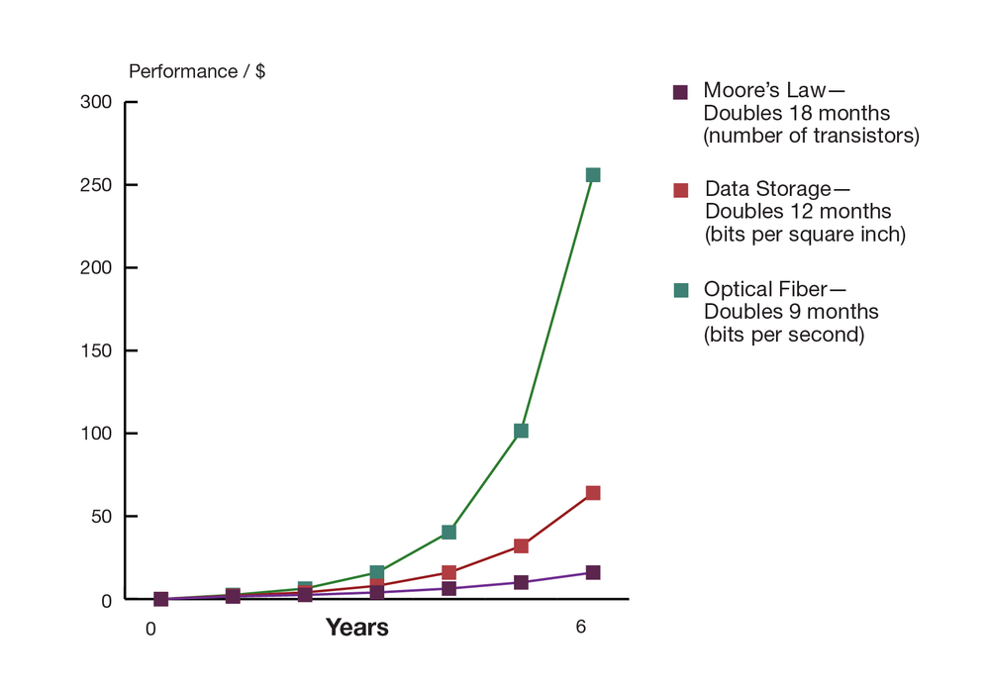
Source: Adapted from Shareholder Presentation by Jeff Bezos, Amazon.com, 2006.
Computer chips are sometimes also referred to as semiconductors
A substance such as silicon dioxide used inside most computer chips that is capable of enabling as well as inhibiting the flow of electricity. From a managerial perspective, when someone refers to semiconductors, they are talking about computer chips, and the semiconductor industry is the chip business.
(a substance such as silicon dioxide used inside most computer chips that is capable of enabling as well as inhibiting the flow of electricity). So if someone refers to the semiconductor industry, they’re talking about the chip business. The term semiconductors is often used to refer to microprocessors and/or chips used for data storage.
Strictly speaking, Moore’s Law does not apply to other non-silicon-based technology components. But other computing components are also seeing their price-versus-performance curves skyrocket exponentially. Data storage doubles every twelve months. Networking speeds also consistently get faster over time. With just an equipment change at the ends of the cables, the amount of data that can be sent over an optical fiber line
A high-speed glass or plastic-lined networking cable used in telecommunications.
has, at times, doubled every nine months. These numbers should be taken as rough approximations and shouldn’t be expected to be strictly precise over time. And predictability precision is tough to achieve. For example, some think the advance in hard-drive storage (sometimes referred to as Kryder’s Law) is decelerating, while others think it is poised to accelerate. Others have claimed that network speeds are now doubling about every twenty-one months. And as mentioned earlier, some say the rate of microprocessor performance relative to Moore’s predictions is either slowing or accelerating, depending on if you’re looking at the same chip architectures or comparing them against newer designs. Despite any fluctuation, it’s clear that the price/performance curve for many technologies has consistently and dramatically increased, offering astonishing improvement over time. While the pace of change may vary, these graphs (or recalibrated versions, if you like) are useful to managers as rough guides regarding future computing price/performance trends. As so many examples in this text have illustrated, managers without an eye on technology’s advancing capabilities are often leading candidates for professional roadkill.

Bits and Bytes
Computers express data as bits that are either one or zero. Eight bits form a byte (think of a byte as being a single character you can type from a keyboard). A kilobyte refers to roughly a thousand bytes, or a thousand characters, megabyte = 1 million, gigabyte = 1 billion, terabyte = 1 trillion, petabyte = 1 quadrillion, and exabyte = 1 quintillion bytes.
While storage is most often listed in bytes, telecommunication capacity (bandwidth) is often listed in bits per second (bps). The same prefixes apply (Kbps = kilobits, or one thousand bits, per second, Mbps = megabits per second, Gbps = gigabits per second, and Tbps = terabits per second).
These are managerial definitions, but technically, a kilobyte is 210 or 1,024 bytes, mega = 220, giga = 230, tera = 240, peta = 250, and exa = 260. To get a sense for how much data we’re talking about, refer to Table 6.1.
Table 6.1 Bytes Defined
 | Managerial Definition | Exact Amount | To Put It in Perspective
1 Byte | One keyboard character | 8 bits | 1 letter or number = 1 byte
1 Kilobyte (KB) | One thousand bytes | 210 bytes | 1 typewritten page = 2 KB
1 Kilobyte (KB) | One thousand bytes | 210 bytes | 1 digital book (Kindle) = approx. 500–800 KB
1 Megabyte (MB) | One million bytes | 220 bytes | 1 digital photo (7 megapixels) = 1.3 MB
1 Megabyte (MB) | One million bytes | 220 bytes | 1 MP3 song = approx. 3 MB
1 Megabyte (MB) | One million bytes | 220 bytes | 1 CD = approx. 700 MB
1 Gigabyte (GB) | One billion bytes | 230 bytes | 1 DVD movie = approx. 4.7 GB
1 Gigabyte (GB) | One billion bytes | 230 bytes | 1 Blu-ray movie = approx. 25 GB
1 Terabyte (TB) | One trillion bytes | 240 bytes | Printed collection of the Library of Congress = 20 TB
1 Petabyte (PB) | One quadrillion bytes | 250 bytes | Master copies of the shows and movies available on Netflix (2013) = 3.14 PB
1 Exabyte (EB) | One quintillion bytes | 260 bytes | Estimated total data stored in the NSA’s Bluffdale, Utah, data center (includes data from hard drives, overseas data centers, cell phones, and more) = 12 EB
1 Zettabyte (ZB) | One sextillion bytes | 270 bytes | Estimated total annual amount of data transmitted over the Internet by 2018 = 1.6 ZB
1 Yottabyte | One septillion bytes | 280 bytes | It’s predicted that by the 2030s, about one yottabyte of data each year will be generated—if a yottabyte were etched onto DVDs and stacked vertically, it would reach all the way to Mars.

Get Out Your Crystal Ball
One of the most important managerial implications of fast/cheap computing is that it makes possible the once impossible. As a manager, your job will be about predicting the future. First, consider how the economics of Moore’s Law opens new markets. When technology gets cheap, price elasticity
The rate at which the demand for a product or service fluctuates with price change. Goods and services that are highly price elastic (e.g., most consumer electronics) see demand spike as prices drop, whereas goods and services that are less price elastic are less responsive to price change (think heart surgery).
kicks in. Tech products are highly price elastic, meaning consumers buy more products as they become cheaper. And it’s not just that existing customers load up on more tech; entire new markets open up as firms find new uses for these new chips, technology becomes embedded in new products, and fast/cheap technology enables new services.
Just look at the evolving waves of computing we’ve seen over the previous decades. In the first wave in the 1960s, computing was limited to large, room-sized mainframe computers that only governments and big corporations could afford. Moore’s Law kicked in during the 1970s for the second wave, and minicomputers were a hit. These were refrigerator-sized computers that were as speedy as or speedier than the prior generation of mainframes, yet were affordable for work groups, factories, and smaller organizations. The 1980s brought wave three in the form of PCs, and by the end of the decade nearly every white-collar worker in America had a fast and cheap computer on their desk. In the 1990s, wave four came in the form of Internet computing; cheap servers and networks made it possible to scatter data around the world at the same time that fast/cheap PCs became mouse-click easy and PC ownership became common in the industrialized world. The following decade saw mobile phones drive what can be considered computing wave five. Cheap processors enabled billions of low-end phones, while the march of Moore’s Law is driving the smartphone revolution. Some say the sixth wave of computing is the era of pervasive computing, where technology is fast and so inexpensive that it is becoming ubiquitously woven into products in ways few imagined years before. And we may be in a seventh wave, where AI via computing in the cloud, enabled by fast telecom, pushes remote brains out to all sorts of “edge” devices. This is bringing about an era of artificial intelligence everywhere, from vision systems in driverless cars to brilliant chatbots in your home speakers, wearable pins, and spatial computing headsets to AI companions that monitor your app use and coding, providing instruction along the way to systems as complex as stock exchanges. Silicon is everywhere! It’s in the throwaway radio frequency identification (RFID) tags that track your luggage at the airport. It’s the brains inside robot vacuum cleaners, it’s built into Legos, it’s in the locks that allow hotel rooms to be opened with a guest’s phone, it’s in the iBeacon sensors that help you find a hot dog and beer at the ballpark and the AirTag that helps you find your misplaced backpack, it’s in smart speakers like Echo and HomePod, and it’s empowering wearables from smartwatches to smart glasses to in-shirt sensors.
For managers, it's important to realize that these digital shifts often constitute disruptive technologies that rearrange entire industries. None of the firms that dominated mini-computing made the transition to other waves of computing. For example, no manufacturers of film cameras successfully lead in digital photography (which most consumers now enjoy as an “add-on” in their mobile phones). The leader in cloud computing is Amazon—a firm that started as an e-commerce retailer. Its still early, but as AI and machine learning grow in prominence, many wonder if OpenAI (behind ChatGPT) will be a new giant, or if AI/ML is simply a feature of the already existing wave of cloud computing. No one said predicting the future would be easy, but too bad, manager. That’s now part of your job!

Tech: A Helping Hand to Escape Poverty
Another tech product containing a microprocessor—the cell phone—is transforming the lives of some of the world’s most desperate poor. Today, some 93 percent of the world’s population has access to a mobile broadband network. That’s more of the world’s population than has access to clean water or electricity, and Moore’s Law, paving the way for sub-$20, Internet-accessing phones, has fueled this availability. According to economist Jeffrey Sachs, “The cell phone is the single most transformative technology for world economic development.” A London Business School study found that for every ten mobile phones per 100 people, a country’s GDP bumps up 0.5 percent. Think about the farmer who can verify prices and locate buyers before harvesting and transporting perishable crops to market; the laborer who was mostly unemployed but with a mobile is now reachable by those who have day-to-day work; the mother who can find out if a doctor is in and has medicine before taking off work to make the costly trek to a remote clinic with her sick child; or the immigrant laborer serving as a housekeeper who was “more or less an indentured servant until she got a cell phone,” enabling new customers to call and book her services.
Three-quarters of the world’s poorest people get their food and income by farming. But isolated rural farmers often suffer from an information asymmetry problem (refer to Chapter 3 “Strategy and Technology: Concepts and Frameworks for Achieving Success”). These farmers traditionally don’t have accurate information on what their products are worth, and in many communities, less scrupulous traders will buy up harvests at far-below-market rates, only to resell them and pocket the profits for themselves. Coming to the aid of farmers, the Ghanaian firm Esoko delivers market prices, farming tips, and other key information via text message on even the lowest-end cell phones. In one study, farmers using Esoko reported a 10 percent increase in revenue. Other reports have revenue increases as high as 25 to 40 percent. Esoko offers a breadth of services that range from helping farmers find transport services to helping buyers locate farmers with goods to sell.
Somaliland Economy—Cashless Economy Transforms Lives
The breakaway region of Somaliland is not recognized by any nation, and its self-printed currency has plummeted in value, resulting in customers’ needing wheelbarrows of cash to make purchases. Mobile money such as Zaad and e-Dahab eliminate the need for paper cash, increase security, and simplify money transfer.
Transcript
When phones can be used as currency for purchases or payments, who needs Visa or, for that matter, a wallet and cash? The M-Pesa mobile banking service, run by Kenya’s Safaricom, allows customers to transfer cash using text messages. Nearly every Kenyan adult has an M-Pesa account, paying for everything from groceries to cab rides to school tuition. The service can also allow family members to quickly and securely send cash across the country. Only four million Kenyans have traditional bank accounts, but twenty-five million use M-Pesa, and upward of 44 percent of Kenya’s GDP flows through the service. M-Pesa is spreading to other regions and is even used in Afghanistan, while similar schemes are offered by firms such as WIZZIT in South Africa, Zaad and e-Dahab in Somaliland, and GCash in the Philippines. The “mobile phone as bank” may bring banking to a billion unserved customers in a few years.
One of the most agile surfers of new generations of computing waves is Apple, Inc.—a firm with a product line that grew so broad, it dropped the word “Computer” from its name. Apple’s keen insight on where trends in computing power and performance are headed is captured in this statement by the firm’s co-founder, the late Steve Jobs: “There’s an old Wayne Gretzky quote that I love. ‘I skate to where the puck is going to be, not where it has been.’ And we’ve always tried to do that at Apple.” The curves above aren’t perfect, but they can point to where the puck is headed, helping the savvy manager predict the future, plan for the impossible to become possible, and act as the disruptor rather than the disrupted.
Apple’s breakout resurgence owes a great deal to the iPod. At launch, the original iPod sported a 5 GB hard drive that Steve Jobs declared would “put 1,000 songs in your pocket.” Cost? $399. Less than six years later, Apple’s highest-capacity iPod sold for fifty dollars less than the original, yet held forty times the songs. By the iPod’s tenth birthday, Apple was giving away 5 GB of storage (for music or other media) for free via its iCloud service. Apple’s high-end iPod models have morphed into Internet browsing devices capable of showing maps, playing videos, and gulping down songs from Starbucks’ Wi-Fi while waiting in line for a latte.
The original iPod has also become the jumping-off point for new business lines, including the iPhone, Apple TV, Apple Watch, iPad, iTunes, the App Store, HomePod, and VisionPro. Surfing the ever-evolving waves of computing has turned Apple into the most valuable company in the United States and the most profitable firm on the planet. Ride these waves to riches, but miss the power and promise of Moore’s Law, and you risk getting swept away in its riptide. Apple’s rise occurred while Sony, a firm once synonymous with portable music, sat on the sidelines unwilling to get on the surfboard. Sony’s stock stagnated, barely moving in six years. The firm has laid off thousands of workers while ceding leadership in digital music (and video) to Apple. We’ll see if Apple can replicate this success with the firm’s VisionPro platform. While the first generation of the product sports a hefty U.S. list price of around $3,500, recall that the first-generation iPhone was $700.
Table 6.2 Tech’s Price/Performance Trends In Action: Amazon Kindle and Apple Music Storage
Amazon Kindle |  | Apple
First Generation | Fourth Generation | iPod | iCloud
250 MB | 2 GB | 5 GB | 5 GB
November 2007 | September 2011 | October 2001 | October 2011
$399 | $79 | $399 | Free
Amazon’s Kindle also dramatically demonstrates Moore’s Law–fueled evolution. The first Kindle sold for nearly $400. Less than four years later, Amazon was selling an updated version for one-fifth that price. Other factors influence price drops, such as being able to produce products and their components at scale, but Moore’s Law and related price/performance trends are clearly behind the price decreases we see across a wide variety of tech products and services.
While the change in hard drive prices isn’t directly part of Moore’s Law (hard drives are magnetic storage, not silicon chips), as noted earlier, the faster and cheaper phenomenon applies to storage, too. Amazon provides another example of creating a once-impossible offering courtesy of the trajectory of price/performance technology curves. The firm’s “Search Inside the Book” feature required digitizing the images and text from thousands of books in Amazon’s catalog. Not only did making books searchable before purchase help customers; titles supporting “Search Inside the Book” enjoyed a 7 percent sales increase over nonsearchable books. Here’s where fast/cheap technology comes in. When the feature launched, the database to support this effort was twenty times larger than any database used by any commercial firm just eight years earlier. For Amazon, the impossible had not just become possible; it became good business.
Here’s another key implication for the curves shown earlier: If you are producing products subject to radically improving price/performance, then these products will rapidly fall in value over time. That’s great when it makes your product cheaper and opens up new markets for your firm, but it can be deadly if you overproduce and have excess inventory sitting on shelves for long periods of time. Dell claims its inventory depreciates as much as a single percentage point in value each week. That’s a big incentive to carry as little inventory as possible, and to unload it, fast!

IoT—the Internet of Things: Tech Is Everywhere!
Figure 6.3 Take Your Meds!
Want to build your own “smart” medicine cabinet? You can do so for less than $20 in parts by following the tutorial and build videos at Gallaugher.com.
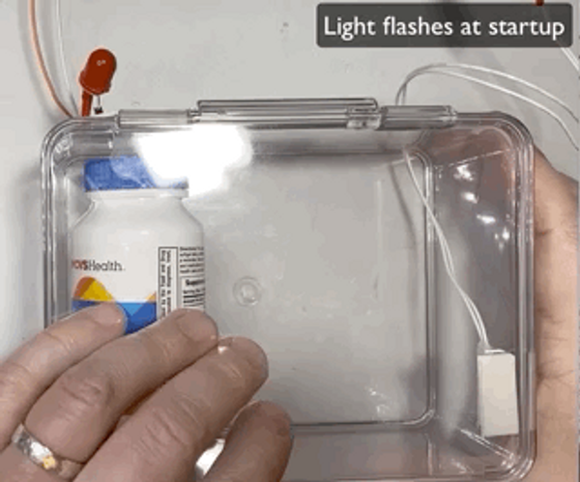
Source: Gallaugher.com: https://gallaugher.com/pi-cabinet/
Show long description
Fast/cheap computing is showing up in all sorts of products. Digital thermostats are commonplace (Google even bought Nest, maker of smart home tech, for $3.2 billion when that firm was only four years old—at the time Google’s second most costly acquisition, ever). Smart billboards in Japan peer back at passersby to guess at their demographics and instantly change advertising for on-the-spot targeting. Dubai’s smart license plates contact paramedics when a car crashes. I teach a course in physical computing (refer to the Circuit Python Tutorials playlist on YouTube) that uses the Raspberry Pi Pico W—a Wi-Fi device that can be programmed in Python and can be used to build robots, art projects, and much more. The Pico starts at just $4, with the Wi-Fi version costing $6—you’ve likely bought coffees that are more expensive. In one exercise, I have my students replicate some of the functionality in the “smart pill bottle” mentioned here, using less than $20 in parts.
Some refer to these new smart devices as the “Internet of Things (IoT)
A vision where low-cost sensors, processors, and communication are embedded into a wide array of products and our environment, allowing a vast network to collect data, analyze input, and automatically coordinate collective action.
,” where low-cost sensors, computing, and communication put embedded smarts in all sorts of mundane devices so that these products can communicate with one another for data collection, analysis, and collective action. We’ve already learned that buying a product from Zara that has an RFID tag attached to it will trigger a message to restock shelves, ship more products from a warehouse, and spin up factories for a new order. And there’s more to come. A driver can now speak to their car to trigger a script that will open a smart garage door, turn on lights so one won’t return to a creepy dark house, reset the thermostat for a person-friendly temperature, and even play relaxing music from your smart speaker. Experimental smart tags in clothing communicate with washing machines and dryers and warn the operator if settings could ruin a shirt. The Internet of Things has also opened new marketplace battlefronts among tech giants, with Google’s IoT standards competing with those used by Apple (HomeKit) and Amazon (via Alexa). We’ll cover competitive issues in the creation of such platforms in Chapter 10 “Platforms, Network Effects, and Competing in a Winner-Take-All World”, as well as key security implications of IoT in Chapter 21 “Information Security: Barbarians at the Gateway (And Just about Everywhere Else)”.
Figure 6.4 The Raspberry Pi
The $6 Raspberry Pi Pico W is a Wi-Fi device that allows you to program IoT projects using the Python programming language.
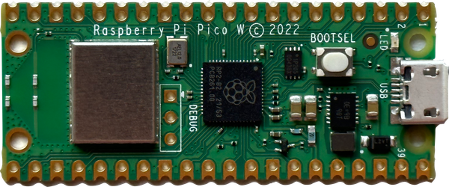
Source: John Gallaugher
Beyond consumer devices, IBM (you’ve seen those “Smarter Planet” ads) and General Electric (GE) are among firms pushing to create technology and common languages to turn this vision into a reality. Cities are using smart devices as constant monitors that share information on traffic, available parking spaces, and water quality. GE is outfitting almost everything it builds—from medical equipment to jet engines—with sensors and software so that these devices can share data and coordinate automatically to drive efficiency. GE thinks efficiency gains across multiple sectors—transportation, health care, energy—could boost global GDP by as much as $10 trillion to $15 trillion by 2030. Research firm IDC estimates that the 35 billion IoT devices in use in 2021 will more than double to 75 billion by 2025, generating an astonishing 79.4 zettabytes of data.

Moore’s Law inside Your Medicine Cabinet . . . and Your Colon
Moore’s Law is coming to your medicine cabinet, and several efforts show the potential for low-cost computing to improve health care quality while lowering costs. GlowCap from Vitality, Inc. (now part of NantHealth), and AdhereTech are just two firms offering a “smart” pill bottle. These firms offer bottles that are programmed to know a patient’s dosage schedule, to trigger refills, and to notify patients, caregivers, or pharmacies when a dosage is missed. Devices might flash, chime, send a text, or prompt a phone call from someone on a person’s health care team. Sometimes the reason for a missed dose is “I forgot,” while other times a patient might stop taking a med due to side effects or a complex insurance reason. AdhereTech’s system will dispatch expert follow-up to help resolve issues so that patients stay on their meds. Incident data is collected for analysis and used in improving care regimes. The AdhereTech system is also free. The business case for that? The World Health Organization estimates drug adherence at just 50 percent, but patients who used “smart” pill bottles reported medication adherence of 98 percent. Analysts estimate that up to $300 billion in increased medical costs and 125,000 annual deaths are due to patients’ missing their meds.
America’s Problem with Getting Patients to Take Their Pills
This CNBC video has good information on the scale of the problem of getting Americans to take their medication and on possible solutions.
Transcript
Figure 6.5 PillCamTM
Swallow the PillCamTM and the device’s twin cameras will relay live video of your insides, helping diagnose gastrointestinal problems.
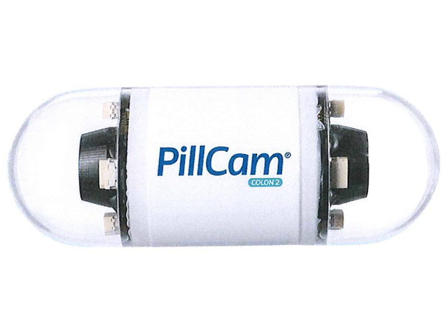
Source: ©2019 Medtronic. All rights reserved. Used with the permission of Medtronic.
And there might also be a chip inside the pills, too! While there is a lot of talk about “wearable” technology, it’s now common for doctors to employ ingestible tech in their practices. Pills with smart sensors are now being used for clinical monitoring, smart drug delivery, and endoscopy diagnostics in fields as diverse as mental health treatment, oncology, and heart disease. The Medtronic PillCam™️ comes with two cameras that, once swallowed, can relay images of your innards, and used to diagnose intestinal and colon problems. During the pandemic, patients received Amazon deliveries of the PillCam so that doctors could perform remote telemedicine by taking a video-tour of a patients intestines and diagnose issues without an office visit.
Your textbook author has ingested a similar device, a Medtronic Bravo™️ Reflux Capsule. No cameras in this one, but it does have sensors and communication smarts to monitor and report on stomach acid. I wore a receiver device around my neck for a weekend, while the heartburn sensor beamed messages through my body from its perch at the end of my esophagus (verdict—no ulcer, but a stomach hernia, ugh). It’s also likely that members of your class (or perhaps you) have an implanted device called a CGM for Continuous Glucose Monitoring—a critical way for patients with diabetes to manage their condition. As the CEO of one ingestible tech pioneer states, you can now think of your body as “the ultimate game controller.”
Figure 6.6 BravoTM Reflux Capsule
This tweet shows the lengths I’ll go to in capturing a teachable moment for you, dear reader.
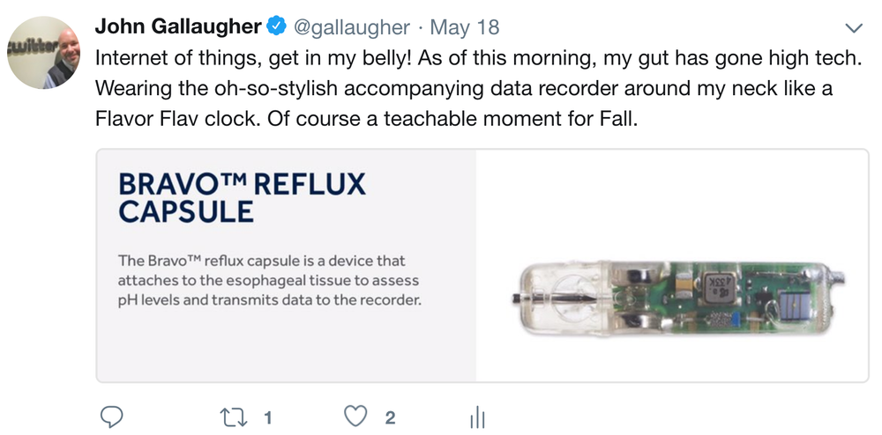
Source: ©2019 Medtronic. All rights reserved. Used with the permission of Medtronic.
Show long description
While the strategic side of tech may be the most glamorous, Moore’s Law impacts mundane management tasks, as well. From an accounting and budgeting perspective, as a manager you’ll need to consider a number of questions: How long will your computing equipment remain useful? If you keep upgrading computing and software, what does this mean for your capital expense budget? Your training budget? Your ability to make well-reasoned predictions regarding tech’s direction will be key to answering these questions.

Key Takeaways
- Moore’s Law applies to the semiconductor industry. The widely accepted managerial interpretation of Moore’s Law states that for the same money, roughly eighteen months from now you should be able to purchase computer chips that are twice as fast or store twice as much information. Or over that same time period, chips with the speed or storage of today’s chips should cost half as much as they do now.
- It’s important to note that even though Moore’s Law in its purest interpretation—the density of transistors on a chip—is slowing down, changes in computing architecture and chip design are still significantly accelerating price and performance while lowering power consumption.
- Nonchip-based technology also advances rapidly. Disc drive storage doubles roughly every twelve months, while equipment to speed transmissions over fiber-optic lines has doubled every nine months. While these numbers are rough approximations, the price/performance curve of these technologies continues to significantly advance.
- These trends influence inventory value, depreciation accounting, employee training, and other managerial functions. They also help improve productivity and keep interest rates low.
- From a strategic perspective, these trends suggest that what is impossible from a cost or performance perspective today may be possible in the future. Fast/cheap computing also feeds a special kind of price elasticity where whole new markets are created. This fact provides an opportunity to those who recognize and can capitalize on the capabilities of new technology. As technology advances, new industries, business models, and products are created, while established firms and ways of doing business can be destroyed.
- Managers must regularly study trends and trajectory in technology to recognize opportunity and avoid disruption.
- Moore’s Law (and related advances in fast/cheap technologies in things like storage and telecommunications) has driven multiple waves of disruptive, market-transforming computing. The cloud-based seventh wave is delivering AI smarts to enterprises and consumers, and the capabilities of these “exo-brains” is also advancing ahead on its own curves.

Questions and Exercises
- What is Moore’s Law? What does it apply to?
- Are other aspects of computing advancing as well? At what approximate rates? What is Kryder’s Law?
- What is a microprocessor? What devices do you or your family own that contain microprocessors (and hence are impacted by Moore’s Law)?
- Why is Moore’s Law slowing? How was Apple to achieve results that were so significant when it launched the M1 chip? Which sorts of devices was the core technology in the M1 chip originally developed for?
- What is a semiconductor? What is the substance from which most semiconductors are made?
- How does flash memory differ from the memory in a PC? Are both solid state?
- What is the difference between volatile and nonvolatile memory? Give examples of each, noting any products that you or your family might own.
- Which of the following are solid-state devices: an iPhone, a USB flash drive, a set-top box with a DVR, a typical laptop PC? Which devices that you or your family have owned have gone from containing moving parts to become solid-state, or now contain more solid state components? Why is this a good thing?
- Why is Moore’s Law important for managers? How does it influence managerial thinking?
- What is price elasticity? How does Moore’s Law relate to this concept? What’s special about falling chip prices compared to price drops for products like clothing or food?
- Give examples of firms that have effectively leveraged the advancement of processing, storage, and networking technology.
- What are the seven waves of computing? Give examples of firms and industries impacted by the sixth and seventh waves.
- As Moore’s Law advances, technology becomes increasingly accessible to the poor. Give examples of how tech has benefited those who likely would not have been able to afford the technology of a prior generation.
- How have cheaper, faster chips impacted the camera industry? Give an example of the leadership shifts that have occurred in this industry.
- What has been the impact of “faster, cheaper” on Apple’s business lines?
- How did Amazon utilize the steep decline in magnetic storage costs to its advantage?
- How does Moore’s Law impact production and inventory decisions?
- Research the impact of mobile phones on poor regions of the world. Come to class prepared to discuss examples that demonstrate the potential for fast/cheap technology to improve society, even for individuals with extremely low incomes.
- The “Internet of Things” is neat, but what implications does this raise for business and society with respect to issues such as privacy and security? If you were GE, would you seek to keep the communication language among smart devices proprietary or open? Why or why not?

6.2 The End of Moore’s Law? Not the End of Fast/Cheap Computing!

Learning Objectives
- Describe why Moore’s Law continues to advance, and discuss the physical limitations of this advancement.
- Name and describe various technologies that may extend the life of Moore’s Law.
- Discuss the limitations of each of these approaches.
As mentioned, Moore’s Law isn’t a precise scientific truth, like Boyle’s Law or relativity. Moore simply observed that we’re getting better over time at squeezing more stuff into tinier spaces, he made a prediction, and it has proven remarkably accurate in pointing to the advance of fast/cheap silicon-based computing across five decades. Moore’s Law is possible because the distance between the pathways inside silicon chips gets smaller with each successive generation. While chip factories (semiconductor fabrication facilities, or fabs
Semiconductor fabrication facilities; the multibillion-dollar plants used to manufacture semiconductors.
) are incredibly expensive to build, each new generation of fabs can crank out more densely packed silicon wafers
A thin, circular slice of material used to create semiconductor devices. Hundreds of chips may be etched on a single wafer, where they are eventually cut out for individual packaging.
. And since the pathways are closer together, electrons travel shorter distances. If electronics now travel half the distance to make a calculation, that means the chip is twice as fast.
While shrinking silicon pathways creates better chips, packing pathways tightly together creates problems associated with three interrelated forces—size, heat, and power—that together are threatening to slow down Moore’s Law’s advance. When you make processors smaller, the more tightly packed electrons will heat up a chip—so much so that unless today’s most powerful chips are cooled down, they will melt inside their packaging. To keep the fastest computers cool, many PCs, laptops, and video game consoles need fans, and most corporate data centers have elaborate and expensive air conditioning and venting systems to prevent a meltdown. A trip through the Facebook data center during its early growth would have shown that the firm was a “hot” startup in more ways than one. The firm’s servers ran at temperatures so high that the Plexiglas sides of the firm’s server racks were warped and melting! The need to cool modern data centers draws a lot of power, and that costs a lot of money.

Keep Cool, Server Farm
Keeping data centers cool is an expensive challenge and has prompted firms to try some very creative approaches. Microsoft has submerged over 850 servers on a patch of seabed, 117 feet underwater off the coast of Scotland’s Orkney Islands, where a clever design lowers temps to about 10 degrees cooler than land-based data centers. Facebook has a data center in Sweden, just 70 miles from the Arctic Circle (average winter temperatures –12°C); data firm Green Mountain has a data center inside a Norwegian mountain, where tech uses a fjord-chilled cooling system; IBM puts heat to good use by warming a public pool outside Zurich; and the Dutch startup Nerdalize says it'll put a mini data center in your home and use the heat to warm your house and heat your bathwater.
These massive data centers, sometimes referred to as server farms, are thought to already draw 5 percent of all energy use in the United States and 18 percent of electricity generated in Ireland. Google’s chief technology officer has said that the firm spends more to power its servers than the cost of the servers themselves. Apple, Facebook, Microsoft, Yahoo!, and Google have all built massive data centers in the Pacific Northwest, away from their corporate headquarters, specifically choosing these locations for access to cheap hydroelectric power. Google’s location in The Dalles, Oregon, is charged a cost per kilowatt hour less than one-fifth the rate the firm pays in Silicon Valley. This difference means big savings for a firm that runs more than a million servers.
And while these powerful shrinking chips are getting hotter and more costly to cool, it’s also important to realize that chips can’t get smaller forever. At some point Moore’s Law will run into the unyielding hand of God, or the laws of physics, if you prefer. While we’re not certain where these limits are, chip pathways certainly can’t be shorter than a single molecule, and the actual physical limit is likely larger than that. Get too small and a phenomenon known as quantum tunneling kicks in, and electrons start to slide off their paths. Yikes! While the death of Moore’s Law has been predicted for years, as mentioned, technologists are advancing fast/cheap computing through better chip design. While not related to Moore’s density of transistors prediction, cloud computing is very much related to the managerial focus on fast/cheap computing. It’s fair to consider the benefit of augmenting a chips’ on-device performance by farming tasks out to massive banks of silicon when contemplating computing performance. Scientists also continue to squeeze advancement through new manufacturing techniques, logical gate design, packaging, and the use of advanced materials.

Manufacturing Chips: Fab Isn't Easy
Silicon smarts and storage are now going into so many devices that by one estimate, the semiconductor industry manufactures more objects in a single year than have been produced by all other factories in all industries in world history. But building high-end chips is becoming increasingly expensive. The cost of a next-generation high-end chip fab can cost upward of $20 billion. Just one component—photo lithography machines that etch ultra-small paths on silicon—can cost as much as $400 million. These machines are the size of a house and require four jumbo jets for delivery. The world’s most precise diamond wire saws are also used to carve wafers from silicon ingots, creating the flattest objects in the world. And fabs are thirsty! A single plant can use millions of gallons of water in a single day, about the same amount of water that a small city uses in an entire year. And this water needs to be ultra-purified before use. Pure water goes in, but doesn’t come out—that water needs to be heavily treated before it can be reused or safely released into the environment. No new fab will get that much water without building an entirely new water processing facility. And water isn't the only pure input for chip manufacture—the air on a chip factory floor is filtered to the point where it's probably a thousand times “more pure” than the air you're breathing now.
This amount of cost requires economies of scale—a plant is only worth it if production can be maxed out. Only eight or fewer firms can afford plants this advanced. Most firms outsource chip manufacturing to specialty firms like TSMC (Taiwan Semiconductor Manufacturing Corporation). Intel is pretty much the only firm with the volume to remain vertically integrated and own its own means of chip production. But concentrating such a large amount of production in a small number of firms creates a defacto oligopoly as well as a security risk. Tension between China and Taiwan and the prospect of technology vital to the economy as well as high-end defense systems has prompted the United States to pass the “Chips and Science” act to encourage the location of semiconductor manufacturing facilities in the United States. It includes roughly $52 billion in subsidies for U.S.-based production, about $24 billion in investment tax credits for domestic chip manufacturing, and over $170 billion for U.S. scientific research. And relocating a fab from Taiwan to the United States isn't as easy as building a multi-billion-dollar plant. TSMC has delayed the opening of a U.S. plant until 2025 because there simply isn't the local talent to run the plant, and a massive workforce will need high-skill training.
How Are Microchips Made?

Buying Time
One way to address the problem of densely packed, overheating chip designs is with multicore microprocessors
Microprocessors with two or more (typically lower power) calculating processor cores on the same piece of silicon.
, made by putting two or more lower power processor cores (think of a core as the calculating part of a microprocessor) to work simultaneously on a single chip. Philip Emma, IBM’s manager of systems technology and microarchitecture, offers an analogy. Think of the traditional fast, hot, single-core processors as a 300-pound lineman, and a dual-core processor as two 160-pound guys. Says Emma, “A 300-pound lineman can generate a lot of power, but two 160-pound guys can do the same work with less overall effort.” For many applications, the multicore chips will outperform a single speedy chip, while running cooler and drawing less power. Multicore processors are now mainstream, and today nearly all smartphones, PCs, and laptops sold have multicore chips.
Know that two brains doesn’t always mean twice as fast. Multicore processors can run older software written for single-brain chips, but they usually do this by using only one core at a time. To reuse the metaphor above, this is like having one of our 160-pound workers lift away, while the other one stands around watching. Multicore operating systems can help achieve some performance gains. Writing code for this “divide and conquer” approach is not trivial. In fact, developing software for multicore systems has been described by Shahrokh Daijavad, software lead for next-generation computing systems at IBM, as “one of the hardest things you learn in computer science.” However, tech firms have come to the rescue, as well. Many software development environments will automatically offload functions to different cores—say playing sound through one core, handling network through another, performing intense calculation through yet another. And most modern operating systems will also divide up tasks they’ve learned to recognize as “divisible.”
Another way of accelerating processing speed is to use chips that are designed to be really good at a subset of tasks. The graphics chip firms Nvidia (pronounced “en-VID-ee-ah”) and AMD were originally designed to do lots of simultaneous calculations necessary for animation and other image work. Many graphics chips have been built with hundreds or in some cases thousands of cores to handle such tasks. And it turns out those multiple, small calculations, while not good for running end-user apps like Word or Excel, are especially well suited for artificial intelligence/machine learning tasks like image and voice recognition. These tasks are usually performed by a bank of interconnected processors located in the cloud, as opposed to on your smartphone or computer. Speak to Siri, Alexa, or say “OK Google,” and your voice is sent over the Internet to be decoded by a collection of computers at Apple, Amazon, or Google, which will then work to find the best result for your query, then send the answer back from the cloud to your device.
While Nvidia dominates the market for AI chips, firms including Google and Amazon have begun designing their own chips to handle their specific AI needs. Terms you might hear in this space include ASICs (pronounced “ay-sicks”), which means “application-specific integrated circuits,” chips specifically designed to be really good at a specific kind of task; and field-programmable gate arrays (FPGAs), which are chips that can be programmed after purchase, rerouting logical pathways for application-specific efficiency in ways that aren’t possible with a general purpose microprocessor like the Intel chip in your laptop (an approach preferred by Microsoft). And while writing “divide and conquer” code to split up tasks to get single, best results is still tricky, new programming environments, such as Nvidia’s CUDA, are making this easier.
The design of transistors themselves has also changed. Engineers have learned to shift the orientation of the transistor vertically, for more space and less leakage, while a technique called RibbonFET wraps the transistor’s gate with material on all four sides. Among the benefits is the ability to change chip design from being paper-flat devices to built-up 3D affairs. Speed increases are achieved from some instructions traveling a small vertical distance rather than a longer end-to-end flat distance. By building up as well as out, firms are radically boosting speed and efficiency of chips. 3D chips are one reason why Philip Wong, vice president of corporate research at chip giant TSMC, states: “Moore’s Law is well and alive. It’s not dead, it’s not slowing down, and it’s not even sick.” Other firms are taking components that had previously been on separate chips, like a portion of RAM that could be used in calculation, or a specialty chip for making fast numerical calculations, and placing these all inside a single, packaged chip.
Table 6.3 Comparison Chart
Microprocessors | ASICs | FPGAs
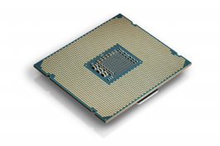 | 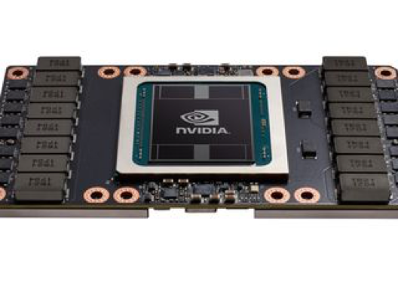 | 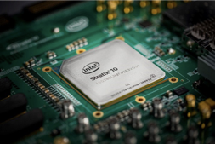
General Purpose Microprocessors: Sometimes called CPUs for central processing units.  Can handle most any tasks, so you'll find them as the “main brain” in your PC (Intel-based) and smartphone (ARM-based).  Pros: Can do just about anything, so they are far better generalists than ASICs or FPGAs. Supported by a large base of existing software.  Cons: Are slower for many tasks, and chips are power-hungry, requiring more energy.  Players: Intel (leader in PCs and servers), ARM (designs are the basis of most smartphone microprocessors, including Apple, Samsung, and Qualcomm). | ASICs: Application-specific integrated circuits are chips designed to do a subset of tasks very quickly and efficiently.  Pros: Very fast and power efficient. Great for graphics and AI/machine learning.  Cons: Can be costly to design and expensive to manufacture a very custom product.  Players: Nvidia and AMD. Google has built its own AI-specific chip (the Tensor processing unit), but only the biggest firms with a specific need for a massive amount of such chips could justify the expense of doing this. | FPGAs: Field-programmable gate arrays can have their on-chip logic re-routed to get better performance for a specific task.  Pros: Faster and more energy-efficient than general purpose microprocessors. Can be upgraded via software “in the field” after installation. A cheaper alternative than designing and manufacturing a custom but unchangeable ASIC.  Cons: ASICs designed from scratch for specific tasks can be faster/more efficient.  Players: Intel-owned Altera, Xilinx. Microsoft uses FPGAs for Bing and other cloud tasks.
Sources: Intel, https://newsroom.intel.com/press-kits/intel-core-x-series-processors/; Altera, https://www.altera.com/about/news_room.html.

Quantum Leaps? Thinking beyond Moore’s Law’s Binary-Calculating Silicon
Think about it—the triple threat of size, heat, and power means that Moore’s Law, perhaps the greatest economic gravy train in history, will likely come to a grinding halt in your lifetime. Multicore and 3D transistors are here today, but what else is happening to help stave off the death of Moore’s Law?
One yet-to-be-proven technology that could blow the lid off what’s possible today is quantum computing. Conventional computing stores data as a combination of bits, where a bit is either a one or a zero. Quantum computers, leveraging principles of quantum physics, employ qubits that can exist in some percentage of both states simultaneously in a state known as superposition, rather like a coin spinning in midair being both one and zero at the same time. Add a bit to a conventional computer’s memory and you double its capacity. Add a bit to a quantum computer and its capacity increases exponentially. For comparison, consider that a computer model of serotonin, a molecule vital to regulating the human central nervous system, would require 1094 bytes of information. Unfortunately there’s not enough matter in the universe to build a computer that big. But modeling a serotonin molecule using quantum computing would take just 424 qubits.
It’s worth noting that most don’t believe quantum computing will replace all digital computing; rather, quantum computers will be used for specialized tasks that they are well suited for. Some speculate that quantum computers could one day allow pharmaceutical companies to create hyperdetailed representations of the human body that reveal drug side effects before they’re even tested on humans. Quantum computing might also accurately predict the weather months in advance, reroute traffic for the most efficient paths, generate more accurate AI, or offer unbreakable computer security. Opportunities abound. Of course, before quantum computing can be commercialized, researchers need to harness the freaky properties of quantum physics wherein your answer may reside in another universe, or could disappear if observed (Albert Einstein himself referred to certain behaviors in quantum physics as “spooky action at a distance”). Quantum computers are also large and require components to be super-cooled to almost absolute zero—meaning for the foreseeable future quantum will exist in the cloud, not inside your smartphone (for a look at an actual quantum computer, refer to the video below, or take a tour of Google’s Quantum Campus).
It can be difficult to assess where we are with quantum computing. Google has already claimed one of its designs has achieved “quantum supremacy”—a term that refers to performing a task that would be practically impossible with conventional computing. Google claims Sycamore, its 53 qubit machine, completed a calculation in just a few minutes that would have taken the world's most powerful supercomputer at the time over 10,000 years to replicate. That's enough to give you the geek goosebumps, but don't get too excited. The task performed was virtually worthless—generating a series of random numbers in a very specific way. IBM, a major Google rival that has more working quantum computers than all other firms combined, hotly disputes the way Google has interpreted its test.
Another problem with quantum computers is that qubits “decohere” or lose their state very quickly, and often contain errors, so advances need to be made to create truly fault-tolerant quantum computers. IBM estimates that to build a computer with the power of 1,000 qubits would require 1 million actual ones. Google and IBM have rival methods to deal with error correction, but no clear winner has emerged. Also, programming quantum computers is entirely different from developing programs for conventional binary devices, so you can't take your Python or Swift code and just drop it on a quantum device. So, simulating advanced pharmaceutical chemistry isn't just around the corner.
IBM already has several paying clients for its quantum computer, including Mercedes, Volkswagen, and the U.S. Department of Energy. You can also try out quantum programming at educational sites from both Google and IBM. And firms are constantly advancing the processing capacity of quantum computers. IBM has already dubbed a sort of Quantum Moore's Law named “Gambetta’s Law,” after Jay Gambetta, its chief quantum theoretician. The “Law” (like Moore’s Law, it's actually just an observation) states that quantum volume is doubling every year. So far so good, but we're still in the very early stages of figuring out if this technology will really deliver on promised super-breakthroughs and industry disruptions. If or when the full promise of quantum computing will become a reality is still unknown, but scientists and engineers are hoping that by the time Moore’s Law runs into Mother Nature’s limits, a new way of computing may blow past anything we can do with silicon, continuing to make possible the once impossible.
The Hype over Quantum Computers, Explained
The quantum computer may become a genuinely disruptive technology, or it may never realize its potential. Here’s a look at the current state of quantum computing, produced by CNBC.
AI: Moore's Law Is Being Decimated
While the video contains lots of speculation, it does a good job of discussing various ways in which the performance curve of technology should continue to advance forward. It also seems quite likely that we’ll see performance in many ways that outstrips what Moore had predicted, if we take transistor density as a proxy for computer performance.
Transcript

Key Takeaways
- As chips get smaller and more powerful, they get hotter and present power-management challenges. And at some point, Moore’s Law will stop because we will no longer be able to shrink the spaces between components on a chip.
- Multicore chips use two or more low-power calculating “cores” to work together in unison, but to take optimal advantage of multicore chips, software must be rewritten to “divide” a task among multiple cores.
- 3D transistors are also helping extend Moore’s Law by producing chips that require less power and run faster.
- New materials may extend the life of Moore’s Law, allowing chips to get smaller. Entirely new methods for calculating, such as quantum computing, may also dramatically increase computing capabilities far beyond what is available today.

Questions and Exercises
- What three interrelated forces threaten to slow the advancement of Moore’s Law?
- Which commercial solutions, described in the previous section, are currently being used to counteract the forces mentioned? How do these solutions work? What are the limitations of each?
- Will multicore chips run software designed for single-core processors?
- As chips grow smaller, they generate increasing amounts of heat that needs to be dissipated. Why is keeping systems cool such a challenge? What are the implications for a firm like Amazon or Google? For a firm like Apple or Dell?
- What are some of the materials that may replace the silicon that current chips are made of?
- Search online to assess the current state of quantum computing. What kinds of problems might be solved if the promise of quantum computing is achieved? How might individuals and organizations leverage quantum computing?
- Watch the video below, which appeared in a recent issue of Scientific American online. This call to action suggests that we are underestimating the implications of quantum computing, and the related ethical implications. Brainstorm social, business, governmental, security, and other challenges that may appear if quantum computing becomes a reality. What should businesses and governments do to prepare for the possibility of quantum computing?
Quantum Ethics: A Call to Action
In this video, The Quantum Daily takes a look at ethics in the field of quantum technology and development, including how the technology can be used for the benefit of the most people possible.

6.3 The Power of Parallel: Supercomputing, Grids, Clusters, and Putting Smarts in the Cloud

Learning Objectives
- Understand the differences between supercomputing, grid computing, cluster computing, and cloud computing.
- Describe how remote, distributed computing changes how we think about computing capacity and what devices can do.
- Recognize that these technologies provide the backbone of remote computing resources used in cloud computing.
- Understand the characteristics of problems that are and are not well suited for parallel processing found in modern supercomputing, grid computing, cluster computing, and multicore processors. Also be able to discuss how network latency places limits on offloading computing to the cloud.
As Moore’s Law makes possible the once impossible, businesses have begun to demand access to the world’s most powerful computing technology. Supercomputers
Computers that are among the fastest of any in the world at the time of their introduction.
are computers that are among the fastest of any in the world at the time of their introduction. Supercomputing was once the domain of governments and high-end research labs, performing tasks such as simulating the explosion of nuclear devices or analyzing large-scale weather and climate phenomena. But it turns out that with a bit of tweaking, the algorithms used in this work are profoundly useful to business.
While some firms own their own supercomputers, others lease capability from cloud providers or even governments. Having vast amounts of computing power is especially advantageous in training and running artificial intelligence models (for more on AI refer to Chapter 18 “Artificial Intelligence—the Tech Impacting Nearly Every Industry”). Other examples (many of which use some type of AI) include simulations, with aerospace firms using supercomputing to design jet engines and aircraft. Appliance manufacturers and auto firms also use supercomputers in product design. Pharma companies use supercomputing in drug simulations and genetic sequencing, and to hunt for previously unidentified behavior in existing drug use. The financial industry regularly uses supercomputing in market and risk simulation, and the oil and gas industry uses these technologies to identify candidate locations for drilling.
You’ll often hear modern supercomputing referred to by the acronym “HPC” for high performance computing. This type of computing is performed via a technique called massively parallel
Computers designed with many microprocessors that work together, simultaneously, to solve problems.
processing (computers designed with many microprocessors that work together, simultaneously, to solve problems). The hardware used in supercomputing can vary—some machines use massive numbers of off-the-shelf processors that can be found in conventional corporate servers, while others use a new generation of hardware. Parallel devices targeted at AI, in particular, will often use specialized chips that are optimized for the type of calculations used in artificial intelligence. Top supercomputers may have chips tweaked for supercomputer use, or contain additional processors that help calculating cores work in unison at high speeds. The hardware used doesn’t look like a conventional desktop computer. Instead, computing hardware are typically mounted vertically on single boards known as blades. Many blades can be slid into several shelves of server racks—shelving that’s stacked inside of individual cabinets about the size of a large refrigerator (refer to video below). The world’s fastest supercomputer as of mid-2023 was Frontier, run by the U.S. Oak Ridge National Lab. Frontier was the first computing device to break the so-called exascale barrier, performing an astonishing 1 quintillion calculations per second (that’s a 1 followed by 18 zeros). Frontier consists of 8,776 chips with 64 cores each, for a staggering 561,664 computing cores working in unison. Specialized networking equipment and cabling, overseen by software designed to support massively parallel tasks, links components so they can act as one. And this bad boy runs hot, requiring six thousand gallons of water to prevent overheating, albeit using a new “green” technique that doesn’t require costly additional cooling.
A Sneak Peek inside Intel’s Supercomputing Lab
Intel’s Aurora computer—built in a partnership with HP Enterprise and the U.S. Department of Energy—will be one of the world’s fastest massively parallel HPCs. Blade computers containing multiple processors are slid into mounted racks and will create a unit capable of performing a billion-billion calculations per second.
Another technology, known as grid computing
A type of computing that uses special software to enable several, often idle computers to work together on a common problem, as if they were a massively parallel supercomputer.
, has allowed organizations to engage in scavenging, or enlisting idle compute time from servers and desktops when they are not in use. Grids can consist of completely different hardware not initially designed to work together, but a software layer allows a computing node in a grid to receive a portion of a common problem and return the calculation for final presentation when done. For example, many firms have created grids that run by turning on idle desktop computing during the evening when employees are away. Organizations have leveraged grid computing to harness supercomputing-caliber capabilities at a low cost and solve all sorts of problems, including Monsanto’s use in biotech modeling, Pratt & Whitney in jet engine design, and Procter & Gamble in consumer product simulation. While grids can offer savings, many of the technologies that lash computers together as a vast, virtual brain have migrated to the cloud, allowing major providers such as Amazon, Google, and Microsoft to offer HPC inexpensively and with more reliability than a firm might gain by CPU scavenging.
Another term you might hear is cluster computing
Connecting server computers via software and networking so that their resources can be used to collectively solve computing tasks.
. Computing clusters are built with commodity servers, but unlike grids, which often use disparate idle resources, clusters are usually made up of groups of similar server computers using special software and networking hardware to more tightly link them together to function as one. The geeky details of how tightly or loosely coupled devices are—and whether this classifies as a grid or a cluster—are less important, but as a manager you should be able to recognize these terms and think critically about their potential use and limitations.
Multicore, massively parallel HPC, grid, and cluster computing are all related in that each attempts to lash together multiple computing devices so that they can work together to solve problems. Think of multicore chips as having several processors in a single chip. Think of massively parallel supercomputers as having several chips in one computer, and think of grid and cluster computing as using existing computers to work together on a single task (essentially a computer made up of multiple computers), with clusters being more “tightly coupled” than grids, with additional software and networking hardware to facilitate their coordination. While these technologies offer great promise, they’re all subject to the same limitation: Software must be written to divide existing problems into smaller pieces that can be handled by each core, processor, or computer, respectively. Some problems, such as simulations, are easy to split up, but for problems that are linear (where, for example, step two can’t be started until the results from step one are known), the multiple-brain approach doesn’t offer much help.
Massive collections of computers running software that allows them to operate as a unified service also enable new service-based computing models, such as software as a service (SaaS)
A form of cloud computing where a firm subscribes to a third-party software and receives a service that is delivered online.
and cloud computing
Replacing computing resources—either an organization’s or individual’s hardware or software—with services provided over the Internet.
. In these models, organizations replace traditional software and hardware that they would run in-house with services that are delivered online. Google, Microsoft, Salesforce.com, and Amazon’s AWS are among the firms that have sunk billions into these Moore’s Law–enabled server farms
A massive network of computer servers running software to coordinate their collective use. Server farms provide the infrastructure backbone to SaaS and hardware cloud efforts, as well as many large-scale Internet services.
, creating entirely new businesses that promise to radically redraw the software and hardware landscape while bringing gargantuan computing power to the little guy (refer to Chapter 16 “Software in Flux: Open Source, Cloud, Virtualized, and App-Driven Shifts”). Researchers have leveraged the technology to, as New Scientist states, “make discoveries scientists can’t” by scanning massive databases of research and hunting for patterns humans have missed. Moving “brains” to the cloud can help increase calculating performance even when we can’t pack more processing brawn into our devices, but the cloud requires a long-distance connection that’s a lot slower and perhaps less reliable than the quick hop from storage to processor that occurs inside most consumer electronics. In tech circles, delay is sometimes referred to as latency
A term often used in computing that refers to delay, especially when discussing networking and data transfer speeds. Low-latency systems are faster systems.
—and low latency is good. It means communications are speedy. Anyone who has experienced a streaming hiccup, has been frustrated by networking speeds’ impacting a video game, or felt that Alexa was just a little too slow in answering a question has likely seen the impact of data round-tripping from a computing device to the cloud and back. Any slow hop along the way—from your local Wi-Fi to something in the server farm, can add latency. But Moore’s Law offers help here, as well. Advances such as chip-based neural engine co-processors used for years in Apple devices have allowed processing that used to require cloud-level parallel work to be performed on the device. This is how your iPhone can snap open when it sees your face, and do this without an Internet connection.

Key Takeaways
- Most modern supercomputers use massive sets of microprocessors working in parallel. While it was common for past supercomputers to use large amounts of server chips that one might have found in high-end corporate computers, today’s AI-focused data centers often use specialty chips targeted specifically to optimizing tasks related to artificial intelligence.
- With the advent of cloud computing, which allows HPC (high performance computing) to be “rented” as needed, organizations as diverse as financial services firms, industrial manufacturers, consumer goods firms, film studios, university researchers, and even startups can now afford access to supercomputer capabilities without having to outright own, run, and maintain the hardware.
- Grid-computing software uses existing computer hardware to work together and mimic a massively parallel supercomputer. Using existing hardware for a grid can save a firm the millions of dollars it might otherwise cost to buy a conventional supercomputer, further bringing massive computing capabilities to organizations that would otherwise never benefit from this kind of power.
- Cluster computing refers to collections of server computers that are linked together via software and networking hardware so that they can function as a single computing resource.
- Massively parallel computing also enables the vast server farms that power online businesses like Google and Facebook, and creates new computing models, like software as a service (SaaS) and cloud computing.
- The characteristics of problems best suited for solving via multicore systems, parallel supercomputers, or grid or cluster computing are those that can be divided up so that multiple calculating components can simultaneously work on a portion of the problem. Problems that are linear—where one part must be solved before moving to the next and the next—may have difficulty benefiting from these kinds of “divide and conquer” computing. Fortunately, many problems such as financial risk modeling, animation, manufacturing simulation, and gene analysis are all suited for parallel systems.
- Many computer tasks can be offloaded to the cloud, but networking speeds (latency)—that is, the time needed to send results back and forth—can limit instances where collections of off-site computing hardware can replace or augment local computing.

Questions and Exercises
- Show your familiarity with key terms: What is High Performance Computing? What are the differences between supercomputing, grid computing, and cluster computing? How are these phenomena empowered by Moore’s Law?
- How does grid computing’s using slack or excess computing resources change the economics of supercomputing?
- Name organizations that are using supercomputing and grid computing. Describe these uses and the advantages they offer their adopting firms. Are they a source of competitive advantage? Why or why not?
- What are the characteristics of problems that are most easily solved using the types of parallel computing found in grids, clusters, and modern-day supercomputers? What are the characteristics of the sorts of problems not well suited for this type of computing?
- You can join a grid, too! Visit the SETI@home website. What is the purpose of the SETI@Home project? How do you participate? Is there any possible danger to your computer if you choose to participate? (Read their rules and policies.) Do some additional research on the Internet. Are there other interesting grid efforts that you can load onto your laptop or even game console?
- Search online to identify the five fastest supercomputers currently in operation. Who sponsors these machines? What are they used for? How many processors do they have?
- What is the advantage of using computing to simulate an automobile crash test as opposed to actually staging a crash?
- Moore’s Law may limit the amount of computing done on the PC, smartphone, AR/VR headsets like Oculus and VisionPro, or gaming consoles that you may own. How can cloud computing make these devices seem more powerful? Give examples of when using a powerful, remote, cloud computing resource might work well to enhance computing on a local device, and mention when the cloud might be less effective. What is the main constraint in your example?

6.4 E-waste: The Dark Side of Moore’s Law

Learning Objectives
- Understand the magnitude of the environmental issues caused by rapidly obsolete, faster, and cheaper computing.
- Explain the limitations of approaches attempting to tackle e-waste.
- Understand the risks firms are exposed to when not fully considering the lifecycle of the products they sell or consume.
- Ask questions that expose concerning ethical issues in a firm’s or partner’s products and processes, and that help the manager behave more responsibly.
We should celebrate the great bounty Moore’s Law and the tech industry bestow on our lives. Costs fall, workers become more productive, innovations flourish, and we gorge at a buffet of digital entertainment that includes music, movies, and games. And we’ve seen that tech offers an opportunity to improve lives in emerging economies.
But there is a dark side to this faster and cheaper advancement. A laptop has an expected lifetime of around two to four years. A cell phone? Eighteen months or less. Rapid obsolescence means the creation of ever-growing mountains of discarded tech junk, known as electronic waste or e-waste
Discarded, often obsolete technology; also known as electronic waste.
, and represents the fastest-growing waste stream on the planet. Each year, we create more than 57 million tons of e-waste. To put that in perspective, the amount of e-waste discarded in just one year is the equivalent of throwing away all of the commercial aircraft ever built throughout history. The outlook is grim—consider that the upgrade to 5G is magnitudes larger than shifts from black-and-white to color TV, or many of the earlier analog-to-digital shifts. Without radical intervention, annual e-waste is expected to more than double in the next three decades, and the results aren’t pretty. Consumer electronics and computing equipment can be a toxic cocktail that includes cadmium, mercury, lead, and other hazardous materials. And crushing flammable lithium-ion batteries in with paper, cardboard, and other fire fuel has led to an uptick in recycling center fires.
Consider how much tech you touch in your lives—not just at home, but at school, work, shopping. In the United States, the e-waste volume amounts to about forty-two pounds per person annually, and while e-waste is only about 2 percent of waste, it represents more than two-thirds of discarded toxic, heavy metals. This “effluent of the affluent” will only increase with the rise of living standards worldwide.
The quick answer would be to recycle this stuff. Not only does e-waste contain mainstream recyclable materials we’re all familiar with, like plastics and aluminum, but it also contains small bits of increasingly valuable metals, such as silver, platinum, and copper. In fact, a ton of discarded iPhone components contains the amount of precious metals that would require more than 2,000 tons of mined material. Done right, recycling produces far less CO2 emissions and other pollution than mining, and it’s thirteen times cheaper to extract precious and rare earth metals from discarded electronics than it is to mine it from the earth.
“Done right” being the key. There’s often a disconnect between consumers and managers who want to do good and those efforts that are actually doing good. The complexities of the modern value chain, the vagaries of international law, and the nefarious actions of those willing to put profits above principle show how difficult addressing this problem will be. Sending e-waste abroad can be ten times cheaper than dealing with it at home, and through 2017, China was recycling some 70 percent of the world’s e-waste, much of it processed in dreadful conditions. The Silicon Valley Toxics Coalition, the Basel Action Network (BAN), and Greenpeace have documented workers without protective equipment, breathing clouds of toxins generated as they burn the plastic skins off of wires to get at the copper inside. Others used buckets, pots, or wok-like pans (in many cases the same implements used for cooking) to sluice components in acid baths to release precious metals—recovery processes that create even more toxins. The area around one site had lead and heavy metal contamination levels some four hundred to six hundred times greater than what international standards deem safe. It was so polluted that drinking water had to be trucked in from eighteen miles away. Pregnancies were six times more likely to end in miscarriage, and 70 percent of the kids in the region had too much lead in their blood. Think you’re working with one of the “good ones”? Each year BAN (the Basel Action Network) exposes the e-waste flow overseas by hiding GPS tracking devices inside equipment dropped off at various recyclers and charity drives (refer to the documentary, “The Circuit: Tracking America’s Electronic Waste”). BAN investigators in Lagos, Nigeria, documented mountains of e-waste with labels from schools, U.S. government agencies, and even some of the world’s largest corporations. And despite Europe’s prohibition on exporting e-waste, many products originally labeled for repair and reuse end up in toxic recycling efforts. The reality is that e-waste management is extraordinarily difficult to monitor and track, and loopholes are rampant.
Tired of being the world’s toxic trash bin, China’s “National Sword” policy put an end to accepting “loathsome foreign garbage” and moved to correct practices in its most notorious recycling regions. However, much of what once went to China simply migrated to other parts of Southeast Asia or Africa. One of the world’s most notorious e-dumps was Agbogbloshie, located in Accra, the capital of the West African nation of Ghana. In Agbogbloshie, “burner boys” as young as twelve eked out a living as electronics scavengers, torching wires to strip casing off metals and breathing smoke clouds and other toxins in conditions just as dreadful as those that had been previously exposed in China. “Shut it down” is often not the best nor easiest solution, and often simply disperses the problem while creating economic hardship for those displaced. When the Ghanaian government raided and plowed over Agbogbloshie, hundreds lost their homes along with their only way of earning a living. Within months, many of the scrappers had simply crossed the river into an area called Old Fadama, or dispersed to smaller centers in the country’s poor north where toxic efforts became even more difficult to uncover and shut down. Sometimes Western outrage captured in a YouTube video doesn’t produce anywhere near the desired solution. Would a more responsible way to address the issue task tech companies to do something like ensuring money paid to a central fund for recycling would end up in the global south, creating industrial zones instead of slums, with health and safety rules, actual jobs, pensions, and other social support? Managers take note—requiring companies to make stronger commitments to the end-of-life (EOL) of their products is almost certainly coming.

American Recycling: Why the United States Is Doing Worse, Not Better
The United States is far worse than other wealthy nations when it comes to recycling. And in many ways the problem is getting worse. With China no longer a buyer of trash, there is now far too much supply of all recyclables. Unlike in the past, when recyclables could be sold for raw material, they have now become worthless waste that municipalities need to pay to have carted away. You can also blame fracking. Natural gas is a key component in producing plastics, and the plummeting cost of natural gas, due to extraction methods like fracking, has made producing new plastics far cheaper, further cratering the market for recyclables. While the European Union and other nations have improved environmental legislation, things in the United States seem to be moving in the other direction. While the Basel Convention on hazardous waste, a treaty that restricts the exports of e-waste, has some 186 signatories, the United States is the only industrial nation that hasn’t signed on. There is no U.S. legislation covering e-waste. The issue is handled by states, and as of 2018 fifteen states didn’t have any e-waste legislation at all.
How 6 Million Pounds of Electronic Waste Gets Recycled a Month
Tour Sims Lifecycle Services in Sims, Tennesee, a woman-owned business on the forefront of automating the gnarly problem of electronics recycling.
Transcript

Yes, You Do Have to Pay Attention to This Garbage, but the “Internet of Trash” May Help
No solutions are big enough to make e-waste issues go away completely, but tech itself will increasingly present solutions to trash problems. It's only in the last year or two that robotics and AI have gotten good enough to be economically viable for high-volume recycling. Waste Management, one of the biggest players in the trash and recycling game worldwide, now uses three different types of robots to separate recycling from contaminants, and in specific tasks they’re doing their job better, quicker, and more cost-effectively than humans.
Moore’s Law means sensors used for detection are now cheaper and more accurate, while machine learning in the cloud continuously improves computer vision and other models so the bots do a better job. This enables tech to help you put garbage in the right place, and can enforce responsibility. The firm Compology makes a smart dumpster that detects if regular garbage has been mixed in with recyclables. Since a single contaminated piece could spoil a whole truckload, recycling firms get a heads up to not haul away the bad stuff, ensuring that corporations take their recycling more seriously. As tech gets cheaper, expect RFID and similar technology to be embedded in products to assist with trash separation. “Smart garbage” would make it easier to separate recyclables, and “smart trash cans” can help do a better job right when items are first thrown away.
Managers will need to think proactively to stay ahead of legislators. While the United States has been lagging in trash law, some regions have been especially aggressive. The push to ban plastic bags, Styrofoam, and drinking straws often makes it easier for a firm to implement a more environmentally friendly policy in all operations, rather than in just the states impacted, so laws passed in one region may have a far larger impact. Globally, European legislation is requiring many tech firms to reclaim products at end-of-life. Already sixty-seven countries have enacted legislation to deal with the e-waste they generate. Managers and product designers are beginning to think about end-of-life as part of the overall design process. It's not much of a leap to imagine a requirement to equip the most toxic or high-valued equipment with yet-to-be-set standard sensor technologies that would make it easier to refuse an item at pickup or separate an item before it hits the landfill. Apple, Google, Samsung, and many other brands have set ambitious targets for recycling and for the use of recycled and renewable materials. Apple claims its Daisy recycling robot can take apart 200 iPhones every hour, and says it diverted 48,000 metric tons of electronic waste from landfills in its first year. Apple has set a goal to make all of its products only from recycled or renewable material. Many of its products are now carbon neutral and use only recycled metals for certain key components, such as aluminum frames and product bodies.
Thinking deeply about the ethical consequences of a firm’s business is an imperative for the modern manager. Big firms are big targets, and environmentalists have been quick to push the best-known tech firms and retailers to take back their products for responsible recycling and to eliminate the worst toxins from their offerings.
How a Robot Recycles Our Electronic Waste
Apple has built several robots. Here is one code-named Daisy, that helps recycle iPhones. One Daisy robot can break down twenty-four models of iPhone, recycling 2.4 million units a year.
Transcript
Environmentalists see this pressure to deal with e-waste as yielding results: Most tech firms have continually moved to eliminate major toxins from their manufacturing processes. All this demonstrates that today’s business leaders have to be far more attuned to the impact not only of their own actions, but also to those of their suppliers and partners. How were products manufactured? Using which materials? Under what conditions? What happens to items when they’re discarded? Who provides collection and disposal? It also shows the futility of legislative efforts that don’t fully consider and address the problems they are meant to target.

Finding Responsible E-waste Disposers
A sting operation led by the U.S. Government Accountability Office (U.S. GAO) found that forty-three American recyclers were willing to sell e-waste illegally to foreign countries, without gaining EPA or foreign-country approval. Appallingly, at least three of them held Earth Day electronics-recycling events.
So how can firms and individuals choose proper disposal partners? Several certification mechanisms can help shed light on whether the partner you’re dealing with is a responsible player. The Basel Action Network (BAN) e-Stewards program certifies firms via a third-party audit, with compliant participants committing to eliminating e-waste export, land dumping, incineration, and toxic recycling via prison labor. The International Association of Electronics Recyclers (IAER) also offers audited electronics recycler certification. And firms certified as ISO 9001 and ISO 14001 compliant attest to quality management and environmental processes. Standards, techniques, and auditing practices are constantly in flux, so consult these organizations for the latest partner lists, guidelines, and audit practices.
Figure 6.7 e-Stewards
The e-Stewards program can help you find a vetted, responsible recycler.
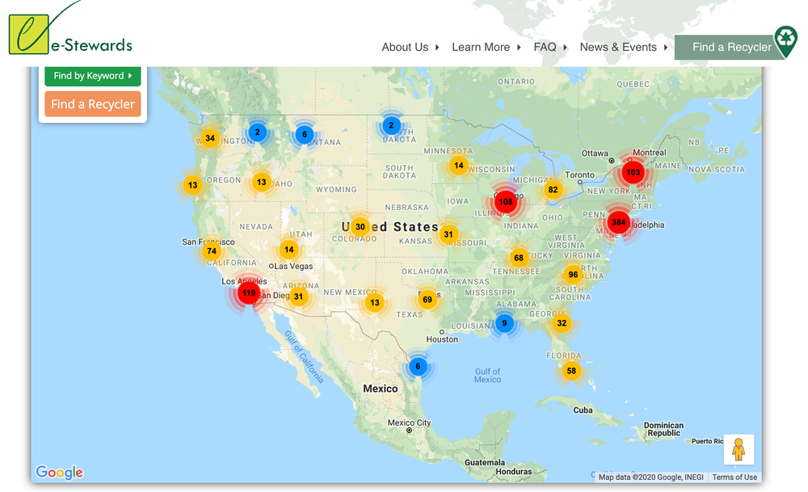
Source: e-Stewards.org; http://e-stewards.org/find-a-recycler/.
Which brings us back to the late Gordon Moore. To his credit, Moore was not just the founder of the world’s largest microprocessor firm and the first to identify the properties we’ve come to know as Moore’s Law; he was also one of the world’s leading supporters of environmental causes. The generosity lives on in the Gordon and Betty Moore Foundation, which, among other major contributions, has given the largest single gift to a private conservation organization. Indeed, Silicon Valley, while the birthplace of products that become e-waste, also promises to be at the forefront of finding solutions to modern environmental challenges. The Valley’s leading venture capitalists, including Sequoia and Kleiner Perkins (where former Vice President Al Gore, an early environmental activist, served as a partner), have started multimillion-dollar green investment funds targeted at funding the next generation of sustainable environmental initiatives.

Key Takeaways
- E-waste may be particularly toxic since many components contain harmful materials such as lead, cadmium, and mercury.
- Managers must consider and plan for the waste created by the products, services, and technology used by their organization. Consumers and governments are increasingly demanding that firms offer responsible methods for the disposal of their manufactured goods and the technology used in their operations.
- Managers must audit disposal and recycling partners with the same vigor as their suppliers and other corporate partners. If not, an organization’s equipment may end up in environmentally harmful disposal operations.
- In some ways, fast/cheap computing is also offering solutions. Robotics and AI can combine to improve waste sorting and resource extraction. New smart bins and other ways to track waste using package bins will also help.

Questions and Exercises
- What is e-waste? What is so dangerous about e-waste?
- What sorts of materials might be harvested from e-waste recycling?
- Many well-meaning individuals thought that recycling was the answer to the e-waste problem. But why hasn’t e-waste recycling yielded the results hoped for?
- What lessons do the challenges of e-waste offer the manager? What issues will your firm need to consider as it consumes or offers products that contain computing components?
- Why is it difficult to recycle e-waste?
- Why is e-waste exported abroad for recycling rather than processed domestically?
- What part does corruption play in the recycling and disposal of e-waste?
- What part might product design and production engineering play in the reduction of the impact of technology waste on the environment?
- What are the possible consequences should a U.S. firm be deemed “environmentally irresponsible”?
- Name two companies that have incurred the wrath of environmental advocates. What might these firms have done to avoid such criticism?
- Research online to find ways, beyond those shown in videos above, in which technology is helping improve the handling of e-waste. Present your finding to your instructor or in class, as requested.

6.5 Mickey’s Wearable: Disney’s MagicBand

Learning Objectives
- Illustrate the value that Disney accrued from embedding technology in otherwise manual experiences.
- Recognize how the experience improved the value of the customer’s Disney World experience.
- Understand some of the issues involved in deploying large-scale information systems in a corporate environment.
Disney executives had a problem—the firm's flagship theme park, Walt Disney World in Orlando Florida, was becoming significantly less fun. Customer surveys cited complaints over long lines, and pricey tickets, and about half of first-time visitors said they would never visit the park again. Ouch! Not good for a theme park self-described as “the most magical place on earth.”
Concerned Disney executives launch the Next Generation Experience project to reverse the trend. The team realized it had very little real-time data on what was happening at the park at a given time in a given location, and data insight would be vital to improving park experiences. The team saw some sort of low-cost electronic wristband as the answer. Moore's Law and other advances in fast/cheap technology were making wireless, wearable products a reality, and a wearable device could provide the real-time data the firm craved, plus all sorts of additional benefits, from identifying customers for hotel, restaurant, ride passes, interaction with staff and attractions, and payment. Years later, the solution was the Disney MagicBand, now a staple of Disney World, Disneyland (the firm’s original California park), Disney Cruise lines, and the product became an onramp for expanding smartphone technologies worldwide. Thanks to the MagicBand, Disney is now armed to leverage tech to streamline your experience, delight you at every turn, and keep you spending money. Satisfaction is boosted along with efficiency and profits, all while cutting costs. The MagicBand provides a useful case study in how Disney pulled off a billion-dollar investment, leveraged Moore’s Law capabilities not just on wrists, but also in phones, hotel door locks, turnstiles, restaurants, and interactive experiences. Data collected from the band provided a massive amount of previously unknown data that could be leveraged in analytics and AI for predictions, park scheduling, operations, service improvements, marketing, and more. In just the first two years after launching, Disney distributed over 30 million MagicBands, making Disney the fourth largest provider of wearable technology.
Bands are used for park and attraction admission, for keyless entry into your Disney hotel or cruise line state room, to pay for rides, whisk luggage to your room, locate your group to deliver restaurant meals, personalize character greetings, match you to photos taken by park photographers and attraction cameras, and more. With MagicBand, ticket fraud is virtually eliminated, as is customer frustration from lost, ripped, or unreadable paper tickets that can occur over multi-day visits. And of course, the tech is tied to your credit card, so you can pay for everything, from an in-park Starbucks fix to gourmet restaurant meals to mouse ears and Frozen dolls, all with a wave of your wrist. Tap-to-pay can be convenient and more secure than wallets or cash that could be lost or more time consuming to use. Studies have also shown that, in general, users of mobile payments spend more—in part because a quick tap detaches consumers from physically handling cash or its plastic representation. The original MagicBand was only offered to guests of Disney World in Orlando, and bands were mailed for free in advance to guests’ homes. The MagicBand is now on its third iteration, known as MagicBand+, and customers are now willing to pay for the device (prices start at $35). MagicBand+ offers color-changing lights, haptic
Relates to touch. Haptic feedback is usually expressed as a tap or vibration delivered by a device as part of the user interface, offering a cue that actions have been taken or a result is available.
feedback, and gesture recognition, with park attractions from the Star Wars Batuu Bounty Hunters to 50 Year Character statues and 100 Year Anniversary Medallions using bands for additional customer experiences. MagicBand+ even syncs to fireworks displays and the Harmonious Nighttime Spectacular at EPCOT. Premium customers willing to shell out for premium services such as Lightning Lane line-skipping services are more likely not to bat an eye at the extra price for wrist-tap entry convenience, but even for customers who don’t choose to buy MagicBands, much of the tech pioneered by the product is available through smartphone apps.
Those opting for bands can choose bands in a rainbow of options customized across the breadth of Disney character offerings. The band box arrives for the family with each guest’s name etched inside their custom wearable. Each band is packed with low-cost, high-powered tech, courtesy of Moore’s Law. MagicBand devices can transmit in a radius of forty feet. The newer MagicBand+ devices have both short- and long-range RFID chip, and a 2.4 GHz radio, akin to what you’d find in an old cordless phone. Devices also have programmable LED lights, a haptic motor for providing vibrating feedback, and an accelerometer for gesture sensing. The new tech draws more power, but bands can now be recharged so guests can start their day at full power.
MagicBands are part of a broader set of technologies that Disney calls MyMagic+ that link various systems that include the Web and mobile My Disney Experience app to plan and share your vacation itinerary, manage your schedule, and deliver GPS park maps and schedules to smartphone apps; the Genie+ ride reservation system; Lightning Lane line-skip premium services; and the Disney PhotoPass that stitches together a custom media album gathered from your visit (with an option to purchase prints, of course). The mandate from Meg Crofton, previous president of Walt Disney World Resort, was to remove the friction in the Disney World experience. Says another Disney exec, “If we can get out of the way, our guests can create more memories.”
With every tap, scanner read, and geo-tracking datapoint, Disney learns more about its customers and can potentially serve them better and more efficiently than competitors who lack similar services. A band or app that tracks users and contains payment information can lead to privacy concerns, but Disney seems to have this covered. Any data collected is anonymized and encrypted. The band itself doesn’t store any personal information; instead, it contains a code that identifies users within Disney’s internal encrypted databases. Lose a band and it can be disabled and replaced. Purchases also require a PIN, and parents concerned with free-spending children can disable purchasing on their bands or set a spending limit.
MagicBand+ Overview

Experience Examples
Enhancing customer experience and delivering more “surprise and delight” moments was at the heart of the MagicBand launch. The debut of MagicBand in Disney World’s Be Our Guest restaurant, inspired by the fairy-tale dining experience in Beauty and the Beast, launched to glowing reviews. Guests arriving at the restaurant are greeted by name by a host who gets a heads-up on their modified iOS device. The welcome is followed by a suggestion to sit wherever you want. The kitchen already has the order you’ve made online. Wireless receivers on the table and in the walls know where you are, so your food is whisked right to you, as if you were Belle herself. All in all, a seamless experience that won top innovation honors from the National Restaurant Association.
MagicBand can also turn a long ride wait into a time-filling interactive experience. Photos taken by park photographers and other in-experience cameras are linked to your band’s ID and will feed images to your My Disney Experience smartphone app, ready for saving or social sharing—a nice way to kill time while waiting in line. The popular EPCOT Test Track ride is notorious for its lines, but clever design fills the wait with a touch-screen auto-design session where users create their own car for integration into the attraction when they’re ready to roll. Guests can also create a custom car commercial. Disney survey data suggests a thirty-five-minute wait time for Test Track feels like it’s only been fifteen to twenty minutes.
Some MagicBand+ experiences will occur automatically. For example, enter the Haunted Mansion and the MagicBand+ will begin pulsing red, like a creepy heart beat. Other locations prompt the user to tap or wave devices next to statues or other attractions, which prompt customers to wave their arms or give another gesture to hear a character message or see a light show. When fireworks start, customers can wave MagicBand+ in front of the display to see their wrists light up and pulse in time with the show. Still others link the MagicBand+ with a smartphone. MagicBand+ devices will pulse green or red, sort of like the child’s game “you’re getting hotter, you’re getting colder” so you can hone in on the location of bad guys to capture when acting as a Star Wars bounty hunter. Hold your smartphone up to nearby walls to nab your quarry, Boba Fett–style.
The Magical Express service is now retired but, for a time, guests could also use their MagicBands as part of the 'Magical Express' luggage transfer service. If packed bands were in your luggage, it would be forwarded to the hotel where an RFID scanner (the UHF chip could be read as far as 10 meters away) identified bags so hotel staff could drop them in your room. You could drop your bags off before boarding your plane, and you wouldn't have to touch them again 'til they showed up in your room when you arrived at a Disney resort, just like magic!

Big Data and Big Benefits
Disney World is really more of a city than a resort. It occupies twice as much land as Manhattan, contains four major theme parks, some 140 attractions, 300 dining locations, and 36 hotels. The fifteen-mile monorail alone hosts an average of 150,000 rides each day. Driving far-reaching delight alongside efficiency at scale is the major goal of the MyMagic+ system that contains the MagicBand+ trip planning and operations technology.
Guests use the park’s website and apps before they show up in Orlando as well as during their stay. The MyDisneyExperience App can be used to plan your itinerary, complete with predicted wait times. Like the MagicBand, the app can also act as your theme park entry, link to credit cards for in-park purchases, and can be used to redeem prescheduled Lightning Lane rides. The app also organizes park photos, including those taken by roaming park photographers as well as sessions with Disney characters. Information from these systems, when coupled with real-time data collected from MagicBand-wearing guests, delivers more insight to tailor many more service improvements than if guests were free-ranging around Disney World without prior planning. Disney analysts saw that some guests were traversing the park upward of twenty times a day to see all the rides they were most interested in. Now park systems crunch data so the Mouse House can craft a custom guest itinerary that eliminates a frustrating zigzag across the many realms of the Magic Kingdom. It also allows booking ride reservations to minimize wait times and spreads out guests to further cut line time. With an average of 8,000 to 10,000 guests flowing through the park’s main entrance every hour, Big Data analytics and efficient scheduling algorithms keep everyone happier. Another benefit to satisfied customers? They’re less likely to decamp for nearby rival parks such as Universal Studios, Sea World, and Legoland.
Data helps Disney know when to add more staff at rides and restaurants; how to stock restaurants, snack bars, and souvenir stands; and how many costumed cast members should be roaming in various areas of the park. If a snafu arises, such as an unexpectedly long line or a restaurant menu change, a custom-crafted alert with alternative suggestions can go out via text or e-mail. At some point, systems might be able to detect when guests have waited too long or otherwise had an unexpectedly frustrating experience, offering a treat coupon or a pass to another ride. These kinds of systems have allowed casinos to turn negative experiences (losing big in slots) into positive ones.
And experiences pioneered at theme parks may turn into other Disney products. For example, some Disney Resorts installed a special Amazon Alexa device that responded to the “Hey Disney!” keyword and could be set up to interact with Disney, Pixar, and Star Wars character voices. The Disney Magical Companion is now available as an Alexa add-on for Amazon Echo and devices offers story telling, interactive adventures, trivia, and more. Are the kids going to have a snow day tomorrow? You might get the update in the voice of Olaf, the snowman from Frozen.
Disney says the MagicBand and supporting systems have cut turnstile transaction time by 30 percent, guests are spending more money, and systems have increased efficiency to the point where Disney World can serve 3,000 to 5,000 additional guests per day. Real-time customer data pumped through Disney machine learning algorithms also improves scheduling of over 80,000 employees across 240,000 shifts each week. When Disney knows when and where a family will eat, they can shift chefs and servers to meet demand and start food so pre-orders are ready right when guests arrive. Accurate staffing where and when employees are needed further boosts customer satisfaction and cuts loss from over-scheduling.

Magical Experiences Cost Serious Coin
These systems don’t come cheap. It’s estimated that Disney spent $1 billion on MyMagic+. Over one hundred systems needed to be integrated to make the park function in a unified, guest-delighting way. The cost just to redesign and integrate the DisneyWorld.com website with MyMagic+ is said to have cost about $80 million.
Moore’s Law turns embedded technology at scale, a once-impossible proposition, into a now-justifiable business-enhancing expense (albeit a big one). More than 28,000 hotel doors needed replacement locks to work with MagicBand. Two dozen workers spent eight months upgrading 120 doors per day, trying to be unobtrusive in properties that boast an 80 percent average guest occupancy rate. Two hundred eighty-three park-entry points also had to be upgraded. More than six thousand mobile devices (mostly iPod Touch and iPads with custom apps) were deployed to support new park systems. Disney World also needed to install more than 30 million square feet of Wi-Fi coverage. According to a source in a Fast Company article, “It was a huge effort to wire a communications infrastructure that was basically the same size as San Francisco.” And you can’t roll out a major tech initiative without making sure your staff knows how to use it. Over 70,000 “cast members” (Disney’s name for its employees) received MyMagic+ training, with 15,000 skilled-up in specifics such as the FastPass+ ride reservation system and later the Genie+ Lightening Lane system ride reservation system and MagicBand merchandising.
Putting tech on the wrist of every guest also adds a marginal cost to everyone coming through the door. The firm spent only four cents each to print paper tickets, but the early prototype for MagicBand came in at $35. Fortunately Moore’s Law, savvy engineering, and buying at scale kicked in, and manufacturing costs for bands fell below $5 for the original MagicBand, a much more tolerable price when tallied against the myriad benefits delivered to each visiting guest. And while customers shell out at least $35 for MagicBand+, Disney has also learned that superfans are willing to spend even more to trick out their wrists. Custom options for MagicBand+ sell for even more, as do an array of personal add-ons such as “MagicBandits”—tiny tags of character themes that clip around the spare holes in your MagicBand strap (think Croc Jibbitz charms, but for your wrist).

Magical Experiences Can Require Magical Coordination
Political challenges can also arise when designing and deploying large-scale systems. Lots of groups have a stake in the outcome, and coordinating differing ideas, opinions, and agendas can be taxing. The MagicBand systems impacted park operations, infrastructure, hotels, and marketing, among many other areas. Disney’s IT group was heavily involved in systems development and operation, and needed to lead integration with many existing systems and the replacement of others. The powerful Imagineering team, the group that designs much of the theme park wizardry that puts the magic in the Magic Kingdom, was also deep into the decision-making. Add to this additional work from third parties, including frog design, a renowned high-end global design consultancy whose prior clients include Apple, Lufthansa, and UNICEF; and tech consulting from Accenture, HP, and Synapse, among others. In such a disparate group, conflict, even among the well intended, was inevitable.
Fortunately, the project benefited from strong executive leadership—a key to many successful transformative projects. The effort was led by Disney’s vice president of business development and had the full support and backing of Disney CEO Bob Iger, who regularly discussed the project with the firm’s board of directors. Iger’s involvement sent a clear message: We’re doing this, and the resources will be there to support the effort. The exploratory team for the Next Generation Experience project, or NGE (the early name for what would develop into MyMagic+ and MagicBand), included some of the firm’s most senior execs in theme park and Disney World management. The core team for the project included senior execs in technology, Imagineering, theme parks, and business development. Disney’s COO has stated the project actually came in a bit under budget, although delays and a staged rollout left many of the originally envisioned features to be introduced over time.

Expanding Offerings and Looking to the Future
Additional services on deck include sharing data so that hosts and costumed cast members can issue birthday greetings, and rollout of even more interaction, such as animatronics that call you by name as you walk up to them. Look for even deeper integration with Disney World areas Pandora, World of Avatar, and Star Wars: Galaxy’s Edge. Disney’s theme park and resort destinations are, collectively, a roughly $29 billion business. The Disney attractions empire is massive and includes theme parks in Anaheim, Paris, Shanghai, Tokyo, and Hong Kong; cruise lines; adventure travel; arcades; and ESPN properties. MagicBands and related technologies are already in use in U.S. theme parks, coast to coast, and on Disney Cruise Lines, but technologies can benefit other attractions even without MagicBand+. Shanghai Disneyland visitors can leverage much of this technology via a mobile phone experience, which better matches with the smartphone use of Chinese customers. Innovations started in the MagicBand initiative have also led to Disney Genie—an app that makes planning a trip to massive Disney World far easier. Simply tell the system your interests—princess experiences for the little ones, EPCOT foodie tours, thrill rides for adults or older kids, and the app will evaluate millions of options and arrive at an optimal plan (no doubt AI is involved behind the scenes). The app will dispense tips and advice throughout a guest’s stay, and will respond to last-minute changes if a guest modifies their interests on-the-fly. Disney parks have an annual admission of over 157 million guests a year. At that scale, innovations and bar-setting experiences have a massive influence on overall customer expectations.
Rivals undoubtedly will adapt versions of Disney’s success to their own offerings. Universal has already introduced its TapuTapu wearable, which vibrates with alerts and includes a screen notifying users when it’s time for their ride—no long queue needed! And Carnival Cruise Lines Expect hired the Disney vice president who led the MagicBand effort. But while players in other hospitality and entertainment markets study Disney in hopes of creating a bit of sorcery of their own, Disney’s fast/cheap tech and data-fueled insights act as rocket fuel to propel their scale and brand advantages toward even more impact than they’d realize without tech magic.

Key Takeaways
- The Disney MagicBand handles many tasks, including park and attraction admission, payment, staff notification for improved service, and security such as hotel room admission.
- These devices aren’t just used for fast “ticket-like” scanning, they also gather data, which is used in analytics and artificial intelligence efforts to further cut costs and improve efficiency. Remember, the front end of the Moore’s law-enabled device also leverages an enormous set of back-end technologies for data capture, analysis, and outbound coordination.
- Deploying a project like MagicBand involves integrating over 100 existing and new systems into the firm’s overall set of information systems. The experience cost roughly $1 billion to deploy.
- Many internal and external groups were involved. Differing opinions and agendas often make large projects politically challenging to coordinate. Having the CEO champion the effort, and senior executives from various groups lead development, helped reduce debilitating infighting and helped the project come in under budget.

Questions and Exercises
- What is the MagicBand? What technology is inside it and what does it do? How do the bands benefit the customer experience? What benefits does Disney realize from the system?
- In addition to designing and creating bands, what else did Disney need to do to pull off this effort? How many systems were involved? What infrastructure needed to be upgraded?
- There’s a lot you can do with technology, but Disney is also crafting a very special, branded experience. Do you think Disney got it right, or does the technology seem like it would interfere with the experience? Why or why not?
- What more can and should Disney do with this technology?
- Large technical projects can be a challenge to design and deploy. Why? How did Disney cut through some of these challenges and eventually deliver a project within goals and within budget?
- How does Disney deal with security and privacy concerns? Do you think these precautions are enough? Why or why not?

